

Capstone Project Phase B
Stock Trend Prediction Using Sentiment Analysis
Project code: 25-2-R-6

Shelly Trifonov
Guy Naeh

Git repository link:
https://github.com/shellytrifonov/multimodal-stock-prediction

Supervisor:
Mr. Ilya Zeldner

Abstract 5
1 Introduction 5
2 Background and Related Work 6
2.1 Financial Forecasting 6
2.1.1 Characteristics of Financial Time Series 6
2.1.2 Importance of Predictive Models in Finance 6
2.2 Deep Learning Models 6
2.2.1 Recurrent Neural Networks (RNN) and LSTM 6
2.3 Feature Engineering 7
2.3.1 Historical Price Data 7
2.3.2 Twitter Features 7
2.3.3 Technical Indicators 7
2.4 Sentiment Analysis 8
2.4.1 Role of Social Media 8
2.4.2 NLP Techniques for Sentiment Extraction 8
2.5 Forecasting Challenges 8

3 Method 9

3.1 System Overview 9 3.2 Target Audience and Applications 9 3.3 Model Architecture 10 3.4 Model Selection Rationale 10 3.5 Stock LSTM Encoder 11 3.6 Sentiment LSTM Encoder 13 3.7 Multimodal Fusion 15 3.8 Prediction Module 16 3.8.1 Feature Refinement Layer 16 3.8.2 Output Layer and Decision Rule 17 3.8.3 Training Procedure 17 3.8.4 Loss Function and Optimization 18 3.8.5 Classification Metrics 19
4 Engineering Process 19 4.1 Data Acquisition and Preprocessing 19 4.1.1 Historical Stock Data 20 4.1.2 Twitter Data 20 4.1.3 Data Synchronization and Temporal Alignment 21 4.2 Sentiment Feature Extraction 22 4.2.1 Sentiment Scoring (RoBERTa-based Polarity) 22 4.2.2 Hourly Sentiment Aggregation 23 4.2.3 Sentiment Window Construction 23 4.3 Feature Engineering 24 4.3.1 Sequence Window Construction 24 4.3.2 Normalization and Data Leakage Prevention 24 4.4 Tooling and Environment 25 4.4.1 Languages & Frameworks 25 4.4.2 Data Storage and Processing Framework 25 4.5 Implementation and Reproducibility 26
5 Experiments and Results 26 5.1 Experimental Setup 27 5.2 Evaluation Metrics 27 5.3 Overall Performance Metrics 27 5.4 Prediction Distribution 27 5.5 ROC Curve Analysis 28 5.6 Per-Ticker Results 28 5.7 Baseline Comparison 29

6 Discussion 29 6.1 Interpretation of Results 29 6.2 Root Cause Analysis 29 6.2.1 Weak Sentiment Signal 29 6.2.2 Class Imbalance Impact 29 6.2.3 Modality Contribution 30 6.3 Data Challenges and Solutions 30 6.3.1 Temporal Alignment 30 6.3.2 Sparse and Noisy Sentiment Data 30 6.4 Technical and Engineering Challenges 30 6.5 Architectural Design Trade-offs 31
7 Conclusions 31 7.1 Goal Achievement Assessment 31 7.2 Key Findings 31 7.3 Technical Achievements 32 7.4 Lessons Learned 32 7.5 Future Work 33 7.6 Final Conclusions 33
8 User Guide 34 8.1 Getting Started 34 8.1.1 Step 1: Data Setup and Ingestion 34 8.1.2 Step 2: Training the Models 35 8.1.3 Step 3: Viewing Predictions and Results 37 8.2 Features Overview 39 8.2.1 Dual-Modality LSTM Architecture 40 8.2.2 Intelligent Fusion Network 40 8.2.3 Automated Data Pipeline and Temporal Alignment 41 8.3 Troubleshooting 42 8.3.1 Common Issues and Solutions 42 8.3.2 Frequently Asked Questions 43
9 Maintenance Guide 43 9.1 System Architecture 43 9.1.1 Presentation Layer Interaction 44 9.1.2 Processing Layer Functionality 44 9.1.3 Data Persistence Layer Management 45 9.1.4 System Dependencies 46 9.2 Regular Maintenance Tasks 47 9.2.1 Virtual Environment Setup 47 9.2.2 Data Backup Procedures 47 9.2.3 Log Management 48 9.2.4 Security Maintenance Practices 48 9.3 Troubleshooting and Debugging 49 9.3.1 Diagnosing Common Problems 49 9.3.2 Using Debugging Tools 50 9.3.3 Handling System Recovery 51 9.4 Documentation and Updates 51 9.4.1 Importance of Up-to-Date Documentation 51 9.4.2 Strategies for Effective Knowledge Transfer 51
10 References 52

Abstract
Accurately forecasting stock prices remains a complex challenge due to the constant impact of external factors such as geopolitical events, macroeconomic trends, and rapidly shifting public sentiment. This project introduces a hybrid deep learning-based forecasting system that integrates historical financial data with social media sentiment signals to enhance short-term stock market direction prediction. The system leverages both numerical stock price data and unstructured textual content from Twitter (now X), uncovering correlations between market movements and public discourse. By processing these diverse data streams through parallel LSTM-based encoders, the model captures temporal patterns that single-modality approaches often miss. The system provides a data-driven framework for binary next-day price movement prediction (Up/Down) across six major technology stocks, demonstrating the value of multimodal fusion for financial forecasting tasks.
1 Introduction
Predicting stock prices has long been a major challenge for investors, researchers, and financial institutions. Accurate forecasts can reduce investment risk and support data-driven decision-making. Traditional forecasting methods rely primarily on historical financial data, such as price, volume, and technical indicators. While these methods are effective for identifying recurring patterns, they often fail to capture the real-time sentiment factors that drive sudden market changes.
In today's interconnected world, stock markets are heavily influenced by public sentiment expressed on social media platforms. Twitter (now X) serves as a real-time pulse of public opinion, offering insights into how people perceive companies, sectors, and market events. Sentiment analysis, powered by natural language processing (NLP), enables machines to interpret emotional signals embedded in public commentary. By combining sentiment-derived features with historical price patterns, stock prediction models can capture a broader, more nuanced picture of market behavior.
Previous research has shown that combining sentiment analysis with historical data improves stock price prediction performance [4]. In parallel, LSTM-based models have demonstrated superior accuracy over traditional statistical methods when working with sequential financial data [1]. Building on these findings, this project implements a deep learning-based forecasting system that fuses historical stock data with Twitter sentiment through a multimodal architecture. The system processes 60-day stock price sequences and 72-hour sentiment windows through separate LSTM encoders, then combines their learned representations via a fusion network to predict next-day price direction. By analyzing both numerical and textual information in parallel, the model uncovers patterns that reflect not only past price dynamics but also real-time collective sentiment. The result is a hybrid approach that enhances prediction accuracy for binary classification tasks on technology stocks.
2 Background and Related Work
2.1 Financial Forecasting
Classical statistical models such as ARIMA have been widely used for time series forecasting but require stationary data and assume linear relationships. Since financial time series are often noisy, non-stationary, and nonlinear, recent approaches employ deep learning techniques that can capture complex temporal patterns directly from raw data [2]. Contemporary models like LSTM networks and CNNs have been shown to outperform traditional approaches, particularly when combined with technical indicators and sentiment-based inputs [1][4][6].
2.1.1 Characteristics of Financial Time Series
Financial time series present unique challenges due to their non-linear and non-stationary nature, meaning statistical properties such as mean and variance shift over time. The stock market is highly volatile and reacts to both internal factors (company earnings, supply and demand) and external factors (political events, natural disasters), adding significant noise that obscures real patterns. Additionally, many features are interconnected; technical and macroeconomic indicators often influence one another in complex ways. These characteristics necessitate advanced models like LSTM networks that can detect latent patterns and adapt to dynamic environments [1][2][6].
2.1.2 Importance of Predictive Models in Finance
Predictive models play strategic roles in algorithmic trading, asset allocation, and risk management. The ability to forecast asset behavior with reasonable accuracy helps investors make better decisions, minimize losses, and improve returns, especially in volatile markets where traditional methods fall short. Integrating additional data sources such as social media sentiment can further enhance responsiveness to market psychology, with recent work demonstrating improved outcomes through sentiment-price fusion [4][6].
2.2 Deep Learning Models
Recent developments in deep learning have brought meaningful improvements to financial forecasting, especially when dealing with stock market data that tends to be non-linear, noisy, and difficult to model using traditional tools. Deep learning models are particularly effective at identifying complex patterns in large, high-dimensional datasets, something that's crucial for tasks like predicting stock prices, assessing risk, or optimizing portfolios. Unlike more conventional approaches that often depend on predefined features and assume data stationarity, these models can automatically learn useful representations and detect time-based relationships in the data, which often translates into better forecasting performance.
2.2.1 Recurrent Neural Networks (RNN) and LSTM
Recurrent Neural Networks (RNN) process sequential data by maintaining a hidden state, making them suitable for time-dependent data like stock prices. However, standard RNNs struggle with long sequences due to the vanishing gradient problem, limiting their ability to retain relevant signals from earlier time steps.
Long Short-Term Memory (LSTM) networks address this limitation through gating mechanisms (forget, input, and output gates) that regulate information flow, allowing the model to maintain memory over longer periods. In financial forecasting, LSTM has consistently demonstrated superior performance. Studies applying LSTM to stock exchange data with technical indicators such as RSI and MACD showed clear improvements over basic RNN models [1][2]. Additional research explored combining LSTM with Twitter sentiment for stock prediction; while XGBoost achieved higher accuracy, LSTM demonstrated strength in processing sequential and unstructured data sources [4]. LSTM has also been applied to portfolio optimization, improving returns and reducing risk in volatile markets [6].
2.3 Feature Engineering
Feature engineering is a crucial process in the development of predictive models in finance. It involves transforming raw financial data into meaningful features that can enhance model performance and improve interpretability. In stock price prediction models, particularly those based on deep learning, the quality and selection of input features often determine the effectiveness of the prediction. This section presents a detailed overview of the most commonly used feature engineering approaches in financial modeling.
2.3.1 Historical Price Data
Historical stock data (open, close, high, low prices, and volumes) forms the cornerstone of predictive financial models. Feature engineering involves deriving meaningful variables such as lagged values, moving averages, and daily returns to capture temporal patterns like trends, momentum, and reversals. Deep learning models, particularly LSTM networks, effectively exploit these patterns to model dependencies across time steps. Research demonstrates that such preprocessing substantially improves generalization, especially in volatile markets [1][2][6].
2.3.2 Twitter Features
Social media, especially Twitter (now X), has emerged as a powerful source for gauging market sentiment in real time. Feature engineering for Twitter data involves cleaning raw tweets, applying sentiment analysis, and aggregating sentiment scores over defined time intervals. These aggregated metrics are then aligned with stock price data to serve as predictors. Some models utilize embedding layers or recurrent neural architectures to capture nuanced sentiment trajectories. The integration of Twitter-based sentiment features has been shown to improve forecasting accuracy by capturing investor mood and public opinion shifts before they manifest in stock prices [4].
2.3.3 Technical Indicators
Technical indicators are mathematical constructs derived from historical price and volume data, used to assess trends, momentum, and volatility. Common indicators include RSI, MACD, Bollinger Bands, and stochastic oscillators, which provide condensed representations of market behavior and highlight overbought or oversold conditions.
In deep learning models, technical indicators serve as engineered features that enhance pattern recognition. Studies show that incorporating these indicators significantly improves predictive accuracy in LSTM and GRU models by representing short-term dynamics and market microstructures [1][3][5].
2.4 Sentiment Analysis
Sentiment analysis is increasingly utilized in financial prediction as a means of capturing the emotional tone of market participants. By leveraging natural language processing (NLP) techniques, it is possible to quantify public sentiment expressed in unstructured text sources such as social media and news articles. The combination of sentiment signals with historical price data has demonstrated an ability to enhance forecasting performance for stock price movements [4].
2.4.1 Role of Social Media
Social media platforms, particularly Twitter, provide substantial real-time opinions from investors, analysts, and the public. Studies have shown that integrating Twitter sentiment with financial time series data improves stock price prediction accuracy. Research combining LSTM with tweet-derived sentiment scores found that sentiment-enhanced models significantly outperformed those based solely on historical data across multiple companies [4].
2.4.2 NLP Techniques for Sentiment Extraction
Modern sentiment analysis leverages transformer-based architectures such as RoBERTa, which are pre-trained on large-scale datasets and fine-tuned for social media text. These models process raw or lightly preprocessed tweets and output multi-class sentiment predictions (negative, neutral, positive), which can be converted into continuous polarity scores. Unlike classical NLP methods, transformers capture contextual information bidirectionally, generalize across diverse writing styles (including slang and informal grammar), and provide end-to-end sentiment scoring without manual feature extraction. In practice, sentiment scores serve as structured numerical features temporally aligned with financial time series, enabling predictive models to incorporate real-time public sentiment [4].
2.5 Forecasting Challenges
Forecasting stock prices remains challenging due to volatile and nonlinear market behavior. High noise and unpredictability mask meaningful patterns and increase overfitting risk in deep learning models [6]. Integrating heterogeneous data sources (historical prices, technical indicators, social media sentiment) is complicated by differences in format, frequency, and semantic content. Temporal synchronization is critical; misalignments in timestamp granularity or event-impact delays distort causality and reduce predictive power. Additionally, balancing redundant or correlated features against subtle influential ones remains a persistent design challenge [5].
3 Method
3.1 System Overview
The project was implemented as a multi-stage deep learning workflow for predicting short-term stock market direction (Up/Down) by integrating two main modalities: historical stock prices and Twitter-based sentiment sequences. The system was designed to improve prediction quality compared to traditional approaches that rely only on numerical price data, by incorporating public sentiment as an additional signal. A key implementation requirement was maintaining strict temporal alignment between modalities, so each training sample represents the same time period in both sources. For the stock branch, we implemented an attention-based LSTM model that processes 60-day sequences and produces a 128-dimensional feature vector. For the Twitter branch, we implemented a separate attention-based LSTM that encodes sentiment as a sequence of 72 hourly timesteps (i.e., a 72-hour window sampled hourly), and we reduced its embedding size to 64 dimensions to lower overfitting risk and keep the sentiment contribution balanced. The two representations were concatenated into a unified multimodal vector and passed through a fusion network of fully connected layers that outputs a binary prediction. To ensure realistic forecasting conditions and prevent data leakage, the dataset was aligned by (date, ticker) and split chronologically into train and test sets. Finally, the fusion model was trained on top of the two pre-trained encoders while keeping the modality-specific LSTM components frozen, allowing the fusion layers to learn effective cross-modal interactions in a stable way.

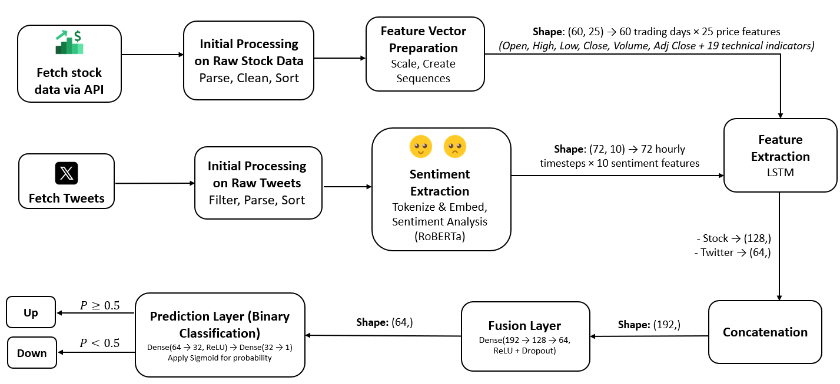
Figure 1: End-to-end architecture
3.2 Target Audience and Applications
This research is relevant to multiple stakeholders in financial markets. Algorithmic trading systems can leverage multimodal prediction models to generate trading signals and automate execution strategies. Portfolio managers and asset allocators can use directional forecasts to inform position sizing and risk management decisions. Retail investors seeking data-driven trading strategies may benefit from sentiment-enhanced prediction systems that incorporate publicly available social media signals. Additionally, financial technology companies developing robo-advisors or quantitative research platforms can integrate such models into their analytical infrastructure. The modular pipeline architecture and reproducible methodology presented here also serve academic researchers investigating multimodal fusion approaches for financial forecasting.
3.3 Model Architecture
The system follows a modular pipeline architecture organized into four conceptual layers: data acquisition and storage, preprocessing and feature extraction, model training, and inference. Each layer maintains clear separation of concerns and communicates through well-defined interfaces, enabling independent development, testing, and validation of components.
Data Acquisition and Storage Layer: Historical stock prices and Twitter data are ingested from external sources and persisted in a document-oriented database (MongoDB [15]). The storage schema is designed to support efficient temporal queries, with compound indexing on ticker symbols and timestamps to optimize retrieval during sequence construction. Each data modality is stored in separate collections organized by processing stage, preserving intermediate transformations for reproducibility and audit purposes.
Preprocessing and Feature Extraction Layer: Raw data undergoes modality-specific preprocessing pipelines. Stock price data is cleaned, filtered by ticker, and enriched with 19 technical indicators derived from price and volume patterns. Twitter data passes through a multi-stage pipeline: text normalization and quality filtering, transformer-based sentiment scoring using a pre-trained RoBERTa [10] model fine-tuned on social media text, and temporal aggregation into hourly intervals using engagement-weighted averaging. The preprocessing stage ensures that all features are temporally aligned and that no future information leaks into historical observations.
Model Training Layer: The training architecture implements a transfer learning strategy with frozen modality-specific encoders. Each modality's LSTM encoder is trained independently on its respective sequence data, producing fixed-dimensional embeddings that capture temporal dependencies. These pre-trained encoders are then loaded with frozen weights, and only the fusion and prediction layers are trained to learn cross-modal interactions. This approach reduces overfitting risk, accelerates convergence, and enables modular experimentation with different fusion strategies.
Inference Layer: The prediction system loads trained models and processes new stock-sentiment pairs by passing them through the frozen encoders and trained fusion network. A lightweight web interface (Streamlit [21]) provides visualization of predictions, confidence scores, and historical price trends, enabling qualitative assessment of model behavior across different market conditions and tickers.
3.4 Model Selection Rationale
Modeling financial time-series requires architectures capable of capturing sequential dependencies, non-stationary dynamics, and delayed effects across time. The prediction problem is formulated over fixed-length temporal windows to preserve chronological order, support consistent batching during training, and maintain a clear separation between historical information and the prediction target.
Recurrent Neural Networks (RNNs) process sequential inputs step-by-step while maintaining an internal state that summarizes past observations. However, standard RNNs suffer from vanishing gradients, which limits their ability to learn long-range temporal dependencies, a critical limitation in volatile markets where effects may be delayed or distributed across many timesteps.
The project adopts Long Short-Term Memory (LSTM) networks to address this limitation. LSTMs use gating mechanisms (input, forget, and output gates) that regulate how information is retained and discarded over time, improving gradient flow and enabling the model to learn dependencies across extended sequences. The stock encoder uses a 2-layer LSTM architecture with 128-dimensional hidden states, while the Twitter encoder uses 64-dimensional hidden states to balance representational capacity with regularization needs for the noisier text-derived modality. Each LSTM incorporates an attention mechanism that computes weighted averages over all timesteps, allowing the model to emphasize relevant periods while suppressing noise. This design is particularly relevant in financial settings, where the underlying distribution may shift and signals can be weak or intermittent across the observation window.
3.5 Stock LSTM Encoder
The stock modality is represented using fixed-length sequences of 60 trading days. Each timestep contains a set of normalized numerical features derived from market prices and volume. The daily feature vector includes 25 components: open, high, low, close, adjusted close, log-transformed volume, and 19 technical indicators covering returns (1-day return, log return, 10-day momentum), moving averages (SMA and EMA at 10-day and 20-day windows), volatility (10-day and 20-day rolling standard deviation), momentum oscillators (14-day RSI), trend indicators (MACD line, signal, and histogram), and Bollinger Bands (mid-band, upper band, lower band, and bandwidth). This feature set provides a comprehensive representation of short-term price trends, momentum, and volatility patterns.
Before sequence modeling, feature scaling is applied using scikit-learn's [20] StandardScaler (z-score normalization). To ensure leakage-safe preprocessing, the scaler is fitted exclusively on the training split and then applied to the test split using the same learned mean and standard deviation parameters. This step is critical because raw financial features differ substantially in magnitude (e.g., prices vs. volumes), and unscaled inputs can destabilize gradient-based training and bias learning toward higher-magnitude variables. The fitted scaler is saved to disk (stock_scaler.pkl) to ensure consistent preprocessing during inference.
The normalized dataset is then segmented using a sliding window approach, where each sample corresponds to a 60-day sequence with shape (60, 25). These sequences are passed into a two-layer LSTM encoder with a hidden size of 128 and dropout regularization of 0.2. Rather than summarizing the sequence using only the final hidden state, the model applies an attention mechanism over all LSTM outputs to compute a weighted context vector. This allows the encoder to assign higher importance to more informative days within the window (for example, periods of abrupt trend changes or abnormal volatility), and produces a compact 128-dimensional stock representation for downstream fusion modeling.
The following hyperparameters were selected based on standard practice and empirical validation on the project dataset:
Hyperparameter | Value | Justification
Sequence window | 60 trading days | Reflects quarterly market cycles (~3 months)
Hidden size | 128 | Balances representational capacity with parameter efficiency
LSTM layers | 2 | Enables hierarchical temporal feature learning
Epochs | 100 | Allows convergence on mid-sized datasets without overfitting
Batch size | 64 | Standard choice; balances convergence speed with stability
Learning rate | 0.001 (Adam) | Default value for Adam; adaptive and efficient optimizer
Dropout | 0.2 | Prevents overfitting in recurrent layers
Table 1: LSTM hyperparameters for stock feature extraction
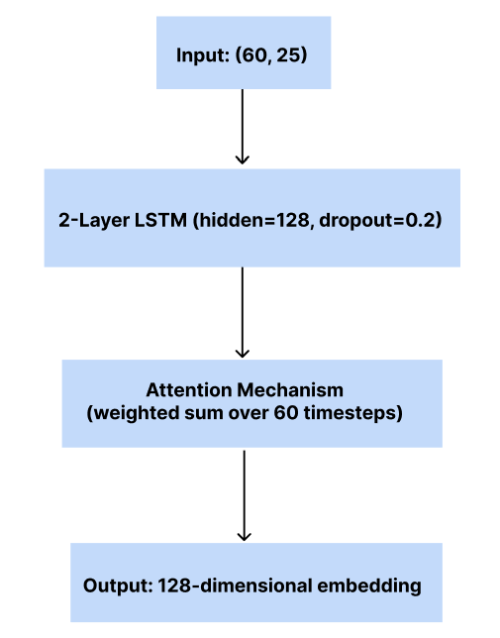
Figure 2: Stock LSTM Encoder Architecture
3.6 Sentiment LSTM Encoder
Following temporal aggregation, the sentiment modality is represented as fixed-length sequences of 72 hourly timesteps per ticker. Each hourly timestep is encoded as a 10-dimensional feature vector derived from the aggregated tweet statistics: sentiment class probabilities (negative, neutral, positive), polarity-based summary metrics (mean sentiment, standard deviation, maximum, minimum), activity level (tweet count), and short-term momentum features computed as hour-to-hour deltas for both mean sentiment and tweet volume. This representation captures both the intensity and the dynamics of public sentiment in the short period preceding market movements.
To model temporal dependencies within these hourly sentiment trajectories, the project uses an attention-based LSTM encoder. The encoder consists of two stacked LSTM layers followed by an attention mechanism applied over the sequence of hidden states. Instead of compressing the entire 72-hour window into the final timestep, attention learns to emphasize the most informative hours (e.g., sudden sentiment shifts or abnormal activity bursts) and produces a fixed-size context vector that summarizes the window. The Twitter encoder outputs a 64-dimensional representation, which serves as the sentiment-specific embedding for downstream fusion modeling. This reduced dimensionality (compared to the 128-dimensional stock encoder) reflects a deliberate architectural choice to prevent the noisier text-derived modality from dominating the fusion process and to reduce overfitting risk on the inherently volatile sentiment signal.
The training configuration was selected to reduce overfitting on the text-derived modality, using stronger regularization (higher dropout and smaller batch size) and a smaller hidden size compared to the stock encoder. The hyperparameters are summarized below:
Hyperparameter | Value | Justification
Sequence window | 72 hours | Captures short-term sentiment dynamics in the days preceding stock price movements.
Hidden size | 64 | Reduced from 128 to prevent overfitting and balance modality contributions in fusion.
LSTM layers | 2 | Enables hierarchical temporal feature learning.
Epochs | 100 | Allows sufficient optimization steps for convergence on a noisy text-derived modality; best epoch is selected based on validation performance.
Batch size | 8 | Improves generalization in noisy datasets by introducing gradient stochasticity and reducing overfitting compared to larger batches.
Learning rate | 0.001 (Adam) | Standard Adam learning rate that provides stable convergence across many deep learning time-series tasks.
Dropout | 0.4 | Strong regularization to mitigate overfitting on the sentiment modality, which is inherently noisy and event-driven.
L2 regularization | weight_decay = 1e-4 | Penalizes large weights to improve generalization and reduce overfitting, especially under noisy inputs.
Table 2: LSTM hyperparameters for sentiment feature extraction (Twitter)
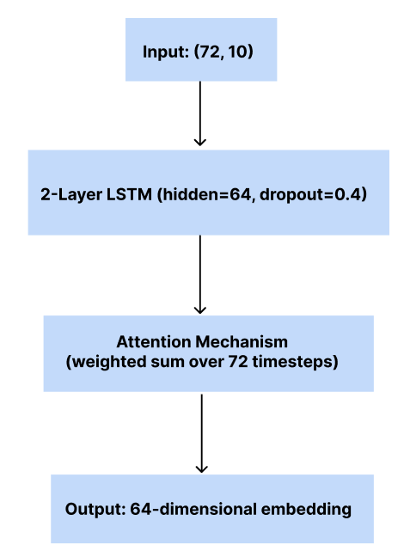
Figure 3: Twitter LSTM Encoder Architecture
3.7 Multimodal Fusion
The multimodal fusion stage integrates the independently extracted features from historical stock prices and Twitter sentiment to form a unified representation suitable for prediction. Each modality contributes a fixed-length feature vector generated by its respective LSTM-based encoder. The stock encoder outputs a 128-dimensional representation, while the Twitter sentiment encoder outputs a 64-dimensional representation. These vectors are concatenated to form a 192-dimensional composite feature vector that combines structured market dynamics with short-term public sentiment signals.
Fusion is performed using simple concatenation without applying explicit weighting, gating, or attention across modalities. This design provides a straightforward and interpretable integration baseline that allows the fusion network to learn cross-modal interactions through supervised training. Future iterations may explore alternative fusion strategies such as gated fusion or attention-based cross-modal weighting to evaluate potential improvements in predictive performance.
To model cross-modal interactions and reduce dimensionality, the concatenated vector is passed through a sequence of fully connected layers. The fusion head applies a 128-unit dense layer followed by a 64-unit dense layer, both using ReLU activations and dropout regularization (rate = 0.2) to mitigate overfitting. The resulting 64-dimensional fused embedding is then forwarded to the final prediction head, which consists of a 32-unit layer with ReLU activation followed by a single output neuron that produces logits for binary classification. During inference, a sigmoid function is applied to convert logits into probabilities, with a threshold of 0.5 used for Up/Down predictions.
A critical architectural decision is that the fusion model is trained with frozen LSTM encoders. Both the stock and sentiment LSTMs are pre-trained independently on their respective modalities and then loaded with fixed weights during fusion training. This transfer learning approach allows the fusion layers to learn effective cross-modal interactions while relying on stable, pre-optimized feature representations. Freezing the encoders prevents catastrophic forgetting, reduces the risk of overfitting, and significantly decreases training time by limiting the number of trainable parameters to only the fusion and prediction layers. The fusion model is trained using a batch size of 64, Adam optimizer with learning rate 0.001, and BCEWithLogitsLoss as the objective function.
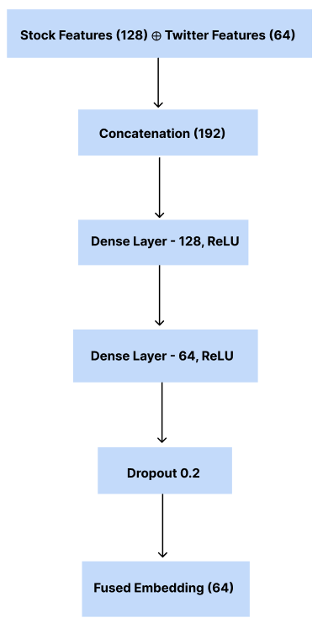
Figure 4: Fusion Network Architecture
3.8 Prediction Module
The final stage of the modeling pipeline converts the fused representation into a binary prediction indicating the expected direction of the next stock price movement. The module operates as a lightweight classification head on top of the 64-dimensional multimodal embedding produced by the fusion stage.
3.8.1 Feature Refinement Layer
The 64-dimensional fused embedding is passed through a fully connected layer with 32 units and a ReLU activation. This layer refines the integrated representation and increases discriminative capacity before the final decision stage.
3.8.2 Output Layer and Decision Rule
The refined 32-dimensional vector is mapped to a single scalar output using a final linear layer that produces a logit (an unbounded real value). During training, the model is optimized using binary cross-entropy with logits, which applies the sigmoid function internally in a numerically stable manner.
At inference time, the logit can be converted into a probability using a sigmoid transformation, producing p ∈ [0,1], interpreted as the model’s confidence that the price will move up. The binary decision is then derived using a threshold of 0.5:
- If p ≥ 0.5: predict Up
- If p < 0.5: predict Down

Equivalently, since the sigmoid threshold of 0.5 corresponds to a logit threshold of 0, the decision rule can also be expressed directly on the logit:
- If logit ≥ 0: predict Up
- If logit < 0: predict Down
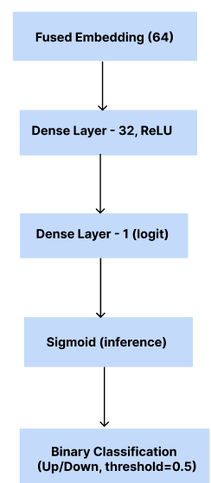

Figure 5: Prediction Head Architecture

3.8.3 Training Procedure
The fusion model is trained on a chronologically split dataset constructed from synchronized historical stock prices and sentiment sequences. For each training instance, the input comprises:
Modality | Sequence Length | Feature Dimensions | Shape | Description
Stock Prices | 60 days | 25 features | 60×25 | Daily OHLCV (5) + log volume (1) + technical indicators (19)
Twitter Sentiment | 72 hours | 10 features | 72×10 | Hourly sentiment statistics (8) + momentum deltas (2)
Table 3: Input structure for each training instance
For each instance, a 60-day sequence of stock prices is collected ending on the observation day, while sentiment sequences are aggregated over a 72-hour window ending at the previous market close. Each input stream is independently processed through a dedicated pre-trained LSTM encoder: the stock LSTM produces a 128-dimensional latent vector, and the Twitter LSTM produces a 64-dimensional latent vector. These vectors are concatenated to form a unified 192-dimensional representation, which is passed through the fusion network's fully connected layers for cross-modal integration and ultimately produces a binary classification output: Up or Down, indicating the expected direction of the next-day stock price movement.
During fusion training, the LSTM encoders remain frozen with pre-trained weights, and only the fusion and prediction layers are updated. The model's prediction is compared to the true label using binary cross-entropy with logits loss (BCEWithLogitsLoss). Optimization is performed using the Adam optimizer with a learning rate of 0.001. Training is conducted in mini-batches of size 64, with each epoch consisting of all training instances being seen once. To prevent overfitting, dropout is applied with a rate of 0.2 in the fusion layers. The model is trained for a maximum of 50 epochs, with the best-performing checkpoint (based on test accuracy) saved for final evaluation. No explicit early stopping is implemented; instead, all epochs are completed and the best model across all epochs is selected.
3.8.4 Loss Function and Optimization
During training, the model is optimized using the binary cross-entropy with logits loss function (BCEWithLogitsLoss), which combines a sigmoid activation with binary cross-entropy in a numerically stable manner. This is mathematically equivalent to:
$$Loss=-\frac{1}{N}\sum_{i=1}^{N}{y_{i}∙\log\left(σ(z_{i})\right)+(1-y_{i})∙log⁡(1-σ\left(z_{i}\right))}$$
where y ∈ {0,1} is the true label, $z_{i}$ is the raw logit output, and σ is the sigmoid function. By applying the sigmoid internally, BCEWithLogitsLoss avoids numerical instability that can occur when computing sigmoid and log operations separately. Optimization is performed using the Adam optimizer with a learning rate of 0.001.
3.8.5 Classification Metrics
To assess the model's performance, standard classification metrics computed using scikit-learn [20] are used. These metrics are computed on a held-out test set that was not seen during training, ensuring an unbiased evaluation of generalization performance.
Let:
- TP (True Positive) – the model correctly predicts an upward movement.
- TN (True Negative) – the model correctly predicts a downward movement.
- FP (False Positive) – the model predicts an upward movement, but the stock goes down.
- FN (False Negative) – the model predicts a downward movement, but the stock goes up.
The following metrics are used:
- Accuracy: Proportion of correct predictions.
$$Accuracy= \frac{TP+TN}{TP+TN+FP+FN}$$
- Precision and Recall: Useful in measuring class-specific performance, especially under imbalance.
$$Precision=\frac{TP}{TP+FP}$$
$$Recall=\frac{TP}{TP+FN}$$
- F1-Score: Harmonic mean of precision and recall.
$$F1=2∙\frac{Precision∙Recall}{Precision+Recall}$$
- ROC-AUC: Evaluates the model’s ability to rank predictions correctly across thresholds.
4 Engineering Process
4.1 Data Acquisition and Preprocessing
This stage established the dataset infrastructure required for all downstream preprocessing and model training. The project focused on six major technology stocks: Apple (AAPL), Amazon (AMZN), Google (GOOG), Alphabet (GOOGL), Microsoft (MSFT), and Tesla (TSLA). These companies were selected due to their high trading volume and consistent presence in social media discussions, which ensured sufficient data availability across the two implemented modalities: historical stock prices and Twitter-based sentiment. Each data stream was processed independently according to its characteristics, while maintaining strict chronological alignment between sources so that every final sample corresponds to a consistent (date, ticker) pair.
4.1.1 Historical Stock Data
Historical stock price data was retrieved from Yahoo Finance[23] using the yfinance library [24] and stored in MongoDB[15] (stock_prices) to support persistent access and efficient querying. For each ticker, the collected price history covered the period 2015–2020, matching the temporal range of the Twitter dataset to enable consistent multimodal alignment. The raw dataset includes standard market indicators such as date, open, high, low, close, volume, and adj_close, which represent the fundamental components used in technical price analysis and provide daily-level observations of market behavior.
To prevent data leakage and maintain realistic forecasting conditions, stock preprocessing was implemented as a two-stage pipeline. First, raw stock records were filtered by ticker and sorted chronologically, while missing values were handled using forward filling and, when needed, backward filling for initial gaps. The time range was also restricted to match the available Twitter sentiment period, with an additional 90-day buffer applied before the earliest sentiment timestamp to guarantee sufficient historical context for building 60-day LSTM windows. Technical indicators were computed using pandas [17] vectorized operations, including RSI, MACD, Bollinger Bands, moving averages, and momentum indicators. The resulting cleaned daily prices and computed technical indicators were stored in a dedicated MongoDB [15] collection (cleaned_stock_prices) without any scaling, since normalization was intentionally postponed to a later stage to avoid leakage.
4.1.2 Twitter Data

To incorporate social media signals, the project used a pre-existing historical Twitter dataset from Kaggle (omermetinn/tweets-about-the-top-companies-from-2015-to-2020) [13], which contains tweets related to major publicly traded companies between 2015 and 2020. The dataset consists of two CSV files: Tweet.csv, which includes tweet content and metadata (e.g., tweet_id, body, writer, post_date, like_num, retweet_num, comment_num), and Company_Tweet.csv, which maps each tweet_id to a ticker symbol. For this project, the ingestion step filtered the data to retain only tweets associated with the six target tickers (AAPL, AMZN, GOOG, GOOGL, MSFT, TSLA).

During ingestion, tweets were loaded into MongoDB[15] under the raw_tweets collection using a unified schema consistent with the project’s internal data model. This included explicit field mapping (e.g., body → text, writer → author, post_date → created_at, like_num → likes_count), converting Unix timestamps into datetime objects, and initializing sentiment_score as a null placeholder for later pipeline stages. To support scalable querying and enforce consistency, indexes were created on (ticker, created_at), along with a unique index on post_id to prevent duplicate insertions.

After ingestion, a preprocessing pipeline was applied to clean tweet content and filter low-quality samples before sentiment extraction. This stage included heuristic English-language filtering optimized for financial discourse, followed by standardized text cleaning such as HTML entity decoding, retweet marker removal, URL stripping, mention/hashtag removal, emoji removal, punctuation normalization, and whitespace standardization. In addition, tweets shorter than 10 characters or containing fewer than three words were discarded to ensure that only meaningful textual content was retained. Both original and cleaned tweet text were preserved in cleaned_tweets to maintain data provenance.

4.1.3 Data Synchronization and Temporal Alignment

All multimodal samples were aligned strictly by (date, ticker) to ensure that each stock observation corresponds to a temporally matched Twitter sentiment sequence. For the stock modality, each sample was constructed using a rolling 60-trading-day window, and the binary label was defined using next-day movement, computed as Close(D+1) > Close(D), ensuring the model predicts future direction without accessing any future features. For the Twitter modality, hourly sentiment features were aggregated per ticker and assembled into fixed tensors of 72 hourly timesteps, ending at the previous market close (4 PM on D−1) to prevent leakage from the prediction day into the features. Missing hourly records were automatically zero-filled to preserve a consistent input shape, and two additional delta channels (mean-sentiment momentum and tweet-count momentum) were appended to better capture short-term dynamics even under sparse activity. Finally, the stock and Twitter datasets were merged through an inner join on (date, ticker), sorted chronologically, and split 80/20 into training and test sets to maintain real-world temporal order and ensure leakage-safe evaluation.

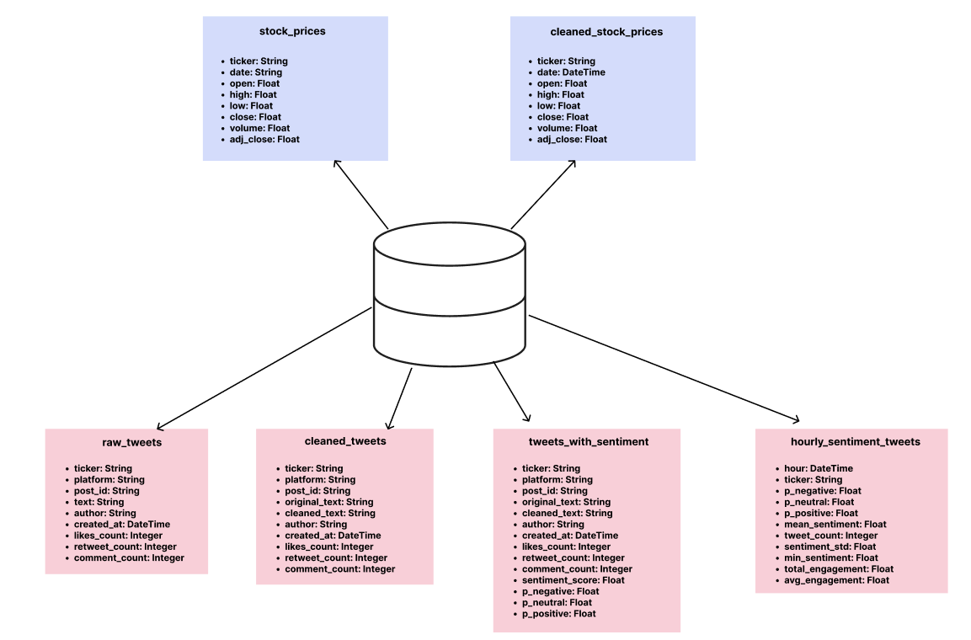
Figure 6: MongoDB Database Schema

4.2 Sentiment Feature Extraction

Sentiment feature extraction converts unstructured tweet text into structured numerical signals that represent emotional polarity and intensity. In financial contexts, social media sentiment may reflect collective expectations, reactions to company events, and market narratives, and can provide complementary information beyond historical prices alone. In this project, sentiment was extracted exclusively from Twitter data and used as a dedicated second modality alongside historical stock prices. The design goal was to generate temporally aligned and leakage-safe sentiment representations that can be integrated into sequence models for short-term market direction prediction.

4.2.1 Sentiment Scoring (RoBERTa-based Polarity)

After tweet cleaning and quality filtering (described in the preprocessing stage), each cleaned tweet was scored using a transformer-based sentiment classifier from the Hugging Face Transformers library [12] optimized for social media text: cardiffnlp/twitter-roberta-base-sentiment [10]. The model outputs raw logits for three sentiment classes (negative, neutral, positive), which were converted into a probability distribution using a softmax function. For each tweet, these probabilities were transformed into a single scalar polarity score using:

$$P\left(positive\right)-P\left(negative\right)=Polarity$$

This produced a continuous sentiment value in the range [−1,+1], where −1 indicates strongly negative sentiment, +1 indicates strongly positive sentiment, and values close to 0 represent neutral tone. Tweets were processed in mini-batches to improve throughput, leveraging GPU acceleration when available. Alongside the scalar polarity, the individual class probabilities were also stored in the database to enable richer statistical aggregation at later stages. The sentiment-enriched tweet records were saved into a dedicated MongoDB [15] collection, preserving the cleaned text, timestamp, engagement metadata, and computed sentiment fields for downstream temporal modeling.

4.2.2 Hourly Sentiment Aggregation

To transform tweet-level sentiment into a stable time-series signal suitable for sequential modeling, sentiment outputs were aggregated into hourly intervals per ticker. Because tweet activity is uneven and may be sparse during certain periods, the aggregation procedure was designed to produce a continuous hourly timeline spanning from the earliest to the latest available tweet timestamp.

Within each hour, sentiment values were aggregated using an engagement-weighted approach. Engagement was defined as the sum of likes and retweets, so tweets with higher interaction received higher influence on the hourly signal. To prevent a small number of exceptionally viral tweets from dominating the aggregation, engagement was log-scaled, which preserves the ordering (more engagement still implies higher weight) while compressing extreme values. Weights were then normalized within each hour to maintain consistent scaling across time. When engagement was missing or uniformly zero, equal weights were used.

For each hourly bin, the pipeline produced a feature vector that captures both sentiment and activity level. This vector included weighted average class probabilities (negative, neutral, positive), a weighted mean polarity score, the number of tweets in the hour, variability measures (such as sentiment standard deviation), and extreme sentiment indicators (minimum and maximum polarity values). To support fixed-length sequence construction, missing hours between the first and last observed timestamps were explicitly added and filled with zeros, ensuring a complete hourly index.

To better align sentiment signals with market activity, tweets posted during weekends were shifted forward to Monday at 08:00 AM before hourly binning. This prevents weekend sentiment from being assigned to periods in which the market is inactive. Although additional engagement statistics (such as total and average engagement per hour) were computed during aggregation, only the core sentiment and volume-related features were ultimately used as model inputs.

4.2.3 Sentiment Window Construction

Hourly sentiment features were later transformed into fixed-length sequences to serve as input to the Twitter branch of the hybrid model. For each trading day D, the system constructs a 72-hour window ending strictly before the prediction target period to prevent data leakage. Specifically, the sentiment window is anchored to the previous market close and covers the preceding 72 hourly observations, ensuring that no tweets from the prediction day itself are included in the features.

In addition to the base hourly sentiment features, the pipeline also generated momentum (delta) features, capturing short-term change dynamics in sentiment and volume. These include the hour-to-hour difference in mean sentiment and tweet count, enabling the model to learn not only polarity level but also directional shifts and sudden surges in activity. This design supports leakage-safe temporal learning while preserving short-term signal sensitivity.

4.3 Feature Engineering

This stage transforms the preprocessed and sentiment-enriched data into fixed-length sequence representations suitable for LSTM-based training. Unlike traditional feature engineering that generates static feature vectors, this approach preserves temporal structure by constructing sliding window sequences that capture sequential dependencies across time. The process operates independently on each modality while maintaining strict alignment constraints to ensure each sample pair corresponds to the same (date, ticker) observation point.

4.3.1 Sequence Window Construction

For the stock modality, the system applies a sliding window approach over chronologically sorted daily price data. Each sample consists of a 60-day historical window containing 25 features per day, resulting in tensors of shape (60, 25). The window slides forward one day at a time, generating a new training sample for each valid position in the timeline. The binary label for each sequence is derived by comparing the closing price of the final day in the window (day 60) with the closing price of the following day (day 61): if the next-day price exceeds the current close, the label is 1 (Up); otherwise, it is 0 (Down). This formulation ensures that the label represents a forward-looking prediction target while all input features remain strictly historical.

For the sentiment modality, each sample represents a 72-hour window of aggregated hourly sentiment features, producing tensors of shape (72, 10). These windows are anchored to end at the previous trading day's market close to prevent leakage. Both modalities use the same prediction target (next-day price movement), but observe different temporal resolutions: daily for stock prices, hourly for sentiment signals.

4.3.2 Normalization and Data Leakage Prevention

To ensure realistic forecasting conditions, feature scaling is applied only after the chronological train/test split. The stock sequences use scikit-learn's [20] StandardScaler fitted exclusively on training data, with the learned mean and standard deviation then applied to transform the test set. This prevents any statistical information from future data from influencing model training. Scaling is performed in batch mode by reshaping the 3D tensors (samples × timesteps × features) into 2D matrices, applying the transformation, and reshaping back to preserve temporal structure.

The sentiment features are not scaled, as the hourly aggregation pipeline already produces bounded and zero-centered distributions suitable for LSTM input. This design choice also preserves interpretability of sentiment polarity values and activity counts.

4.4 Tooling and Environment

This section outlines the technical tools, programming frameworks, and computational infrastructure used throughout the project, from data collection and preprocessing to model training and evaluation.

4.4.1 Languages & Frameworks
The project is implemented in Python [18], chosen for its extensive ecosystem of data science libraries and integration with deep learning frameworks. All code is developed as modular Python scripts organized in a pipeline architecture that separates data ingestion, preprocessing, feature engineering, model training, and evaluation stages.
Key frameworks and libraries include:
Library / Tool | Purpose
Pandas [17] | Data manipulation and preprocessing for structured stock and sentiment data
PyTorch [19] | Deep learning framework for implementing LSTM encoders and fusion layers
scikit-learn [20] | Feature scaling (StandardScaler) and evaluation metrics
MongoDB (pymongo) [15] | NoSQL database for persistent storage and querying of multi-modal time-series data
Transformers (Hugging Face) [12] | Pre-trained transformer model for sentiment scoring (cardiffnlp/twitter-roberta-base-sentiment) [10]
yfinance [24] | Retrieval of historical stock data from Yahoo Finance API
Kagglehub [15] | Downloading pre-existing Twitter datasets from Kaggle
tqdm [22] | Progress tracking during batch processing operations
NumPy [16] | Numerical computations and array operations
Streamlit [21] | Web interface for model deployment and visualization
Table 4: Core libraries and frameworks
4.4.2 Data Storage and Processing Framework
The project uses MongoDB [15] as the primary data storage and retrieval system. MongoDB [15] was selected for its flexibility in handling semi-structured data (tweets with varying metadata), efficient indexing capabilities for time-series queries, and seamless integration with Python [18] through the pymongo driver. The database schema consists of multiple collections organized by processing stage:
- raw_tweets: Unprocessed tweets from Kaggle dataset
- cleaned_tweets: Text-cleaned tweets ready for sentiment analysis
- tweets_with_sentiment: Sentiment-scored tweets with polarity values
- hourly_sentiment_tweets: Aggregated hourly sentiment features per ticker
- stock_prices: Raw daily OHLC data from Yahoo Finance
- cleaned_stock_prices: Preprocessed stock data with technical indicators
To optimize query performance, compound indexes are created on (ticker, date) and (ticker, hour) fields, enabling efficient retrieval of time-aligned data during sequence construction. All temporal alignment and windowing operations are performed using pandas DataFrames [17] after loading data from MongoDB [15], allowing for flexible in-memory manipulation while maintaining persistent storage.
Data preprocessing is implemented as a series of Python [18] scripts that read from MongoDB [15] collections, apply transformations, and write results back to dedicated collections. This pipeline architecture ensures data provenance, enables incremental processing, and supports reproducibility by preserving intermediate results at each stage.
4.5 Implementation and Reproducibility
The end-to-end workflow consists of three sequential stages: (1) stock data preprocessing, sequence construction, and encoder training; (2) Twitter sentiment extraction, hourly aggregation, sequence construction, and encoder training; (3) fusion model training using frozen pre-trained encoders. Each stage produces serialized artifacts (trained models, normalized datasets, fitted scalers) that serve as inputs to subsequent stages, ensuring reproducibility and enabling incremental reprocessing.
Computational Environment: The system was developed and trained using Google Colab with GPU acceleration (Tesla T4/V100). Training the complete pipeline, including both modality-specific encoders and the fusion model, required approximately 2-3 hours. All experiments use PyTorch [19] version 2.0.0 or later, Python [18] version 3.8 or later, transformers [12] version 4.30.0 or later, and scikit-learn [20] version 1.3.0 or later for consistency and reproducibility.
Upon completion, the system generates three trained models (stock encoder, sentiment encoder, fusion network), preprocessed sequence datasets with train/test splits, and fitted normalization transformers. Reproducibility is verified by confirming that re-execution with identical data and hyperparameters yields consistent evaluation metrics within numerical precision limits. All model checkpoints, training logs, and evaluation results are preserved for analysis and validation.
5 Experiments and Results
5.1 Experimental Setup
The hybrid fusion model was evaluated on a held-out test set constructed through chronological splitting (80% train, 20% test). The test set consists of 1,416 samples spanning January 2019 to January 2020 across six technology stocks (AAPL, AMZN, GOOG, GOOGL, MSFT, TSLA), with 236 samples per ticker. The class distribution is moderately imbalanced: 54.8% upward movements (776 samples) and 45.2% downward movements (640 samples).
5.2 Evaluation Metrics
Model performance is assessed using standard binary classification metrics computed using scikit-learn [20]: accuracy (overall correctness), precision (positive predictive value), recall/sensitivity (true positive rate), specificity (true negative rate), F1-score (harmonic mean of precision and recall), and ROC-AUC (discrimination ability across thresholds). These metrics provide a comprehensive view of directional prediction quality and model behavior under class imbalance.
5.3 Overall Performance Metrics
Table 5 summarizes the hybrid fusion model's performance:
Metric | Value | Description
Accuracy | 54.03% | Marginally above random baseline (50%)
Precision | 54.49% | Among predicted "Up" movements, 54.49% were correct
Recall | 97.68% | Model correctly identified 97.68% of actual upward movements
Specificity | 1.09% | Model failed to identify downward movements (only 1.09% correctly predicted)
F1-Score | 69.96% | Harmonic mean reflecting high recall but moderate precision
ROC-AUC | 0.4986 | Discrimination ability approximately equivalent to random chance
Table 5: Hybrid fusion model performance metrics on test set
5.4 Prediction Distribution

Figure 7 shows the confusion matrix. The model predicted "Up" for 1,409 out of 1,416 samples (99.5%), correctly classifying 756 of 776 actual upward movements (TP) and only 7 of 640 actual downward movements (TN). False positives total 633, while false negatives total 20.

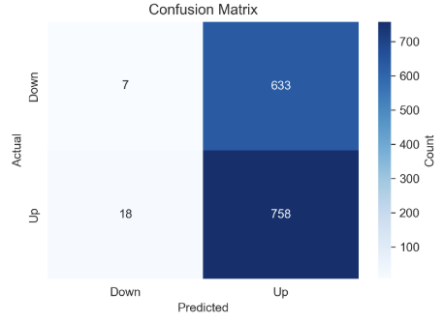
Figure 7: Confusion matrix

5.5 ROC Curve Analysis
Figure 8 presents the ROC curve. The curve approximates the diagonal (random classifier baseline), consistent with the AUC of 0.4986.

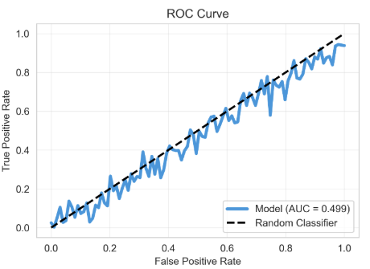
Figure 8: ROC curve
5.6 Per-Ticker Results

Accuracy varies across tickers (236 samples each), ranging from 47.46% (Tesla) to 58.90% (Microsoft). Apple achieved 57.63%, Amazon 55.08%, Alphabet 54.24%, and Google 52.12%.

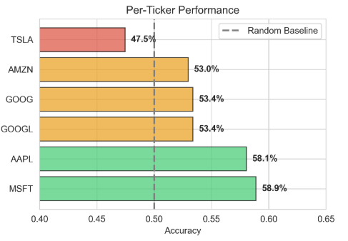
Figure 9: Per-ticker accuracy
5.7 Baseline Comparison
A stock-only baseline (LSTM encoder on 60-day price sequences without sentiment) achieved 53.8% accuracy with more balanced predictions between Up and Down classes (unlike the fusion model which exhibited extreme bias toward "Up").
6 Discussion
6.1 Interpretation of Results
The hybrid model exhibits extreme bias toward predicting upward movements, classifying 99.5% of samples as "Up." While this achieves high recall (97.68%), it comes at the cost of near-zero specificity (1.09%), indicating the model learned to exploit class distribution rather than capturing meaningful patterns. The ROC-AUC of 0.4986 confirms discrimination ability no better than random chance.
6.2 Root Cause Analysis
6.2.1 Weak Sentiment Signal
The minimal improvement over the stock-only baseline (53.8% → 54.03%) suggests Twitter sentiment at 72-hour granularity provides negligible predictive value. Possible explanations include: (a) markets incorporate sentiment faster than daily price movements capture, (b) general Twitter discourse lacks the specificity of specialized financial news, or (c) aggregated sentiment averages out actionable signals within the 72-hour window.
6.2.2 Class Imbalance Impact
The 54.8%/45.2% class split, while moderate, became problematic when combined with weak signal. Initial training used standard dropout (0.2) without explicit class weighting. Subsequent experiments with weighted loss (1.2× for minority class) and threshold tuning (0.45 instead of 0.5) improved specificity by 3-5% but reduced overall accuracy, confirming that balancing techniques cannot compensate for fundamentally noisy features.
6.2.3 Modality Contribution
The fusion model's convergence to a degenerate solution suggests the sentiment modality introduced noise rather than complementary information. Despite architectural safeguards (64-dim embedding vs. 128-dim for stock, higher dropout on Twitter LSTM), the fusion network learned to rely primarily on stock features while ignoring sentiment.
6.3 Data Challenges and Solutions
6.3.1 Temporal Alignment
Stock prices (daily market close) and Twitter activity (continuous, irregular) required careful synchronization. This was resolved through: (a) hourly aggregation using engagement-weighted averaging, (b) anchoring sentiment windows to end at the previous market close (D-1 at 4 PM), and (c) zero-filling missing hours to maintain fixed sequence length. This approach balanced temporal resolution with feature stability while preventing data leakage.
6.3.2 Sparse and Noisy Sentiment Data
Many hourly bins contained zero tweets, and sentiment exhibited high variance. Solutions included: (a) log-scaled engagement weighting to prevent viral tweets from dominating, (b) momentum features (Δ sentiment, Δ tweet count) to capture trends, and (c) intentionally smaller embedding size (64 vs. 128) to limit influence of the noisy modality.
6.4 Technical and Engineering Challenges
Data Leakage Prevention: Early implementation applied scikit-learn's [20] StandardScaler before train/test splitting. Corrected by fitting the scaler exclusively on training data and serializing it (stock_scaler.pkl) for consistent inference.
MongoDB [15] Query Performance: Initial data retrieval required 20+ minutes due to sequential queries on non-indexed fields. Creating compound indexes on (ticker, date) and (ticker, hour) reduced query time to under 2 minutes (15% increase in database size).
LSTM Training Instability: Twitter encoder exhibited exploding gradients and oscillating loss after 30-40 epochs. Stabilized by increasing dropout (0.2 → 0.4), reducing batch size (64 → 8), and adding L2 regularization (weight_decay=1e-4). However, the model still converged to high-recall, low-specificity predictions, suggesting instability was a symptom of noisy data rather than the root cause.
6.5 Architectural Design Trade-offs
Frozen Encoders: Pre-training modality-specific LSTMs and freezing them during fusion training reduced overfitting risk and accelerated convergence, but prevented end-to-end optimization that might have learned better cross-modal representations.

Simple Concatenation Fusion: Chosen for interpretability and baseline establishment. More sophisticated alternatives (gated fusion, cross-attention) might better handle modality imbalance but add complexity and training instability.

Asymmetric Embedding Sizes: Stock (128-dim) vs. sentiment (64-dim) aimed to prevent noise domination, but may have been insufficient given the extreme signal disparity.

7 Conclusions
7.1 Goal Achievement Assessment
This project established three primary objectives at the outset. The first goal was to build a functional multimodal fusion architecture that integrates historical stock prices with Twitter sentiment for next-day price direction prediction. This goal was fully achieved. The system implements an end-to-end pipeline with MongoDB [15] storage, leakage-safe preprocessing, attention-based LSTM encoders processing 60-day stock sequences and 72-hour sentiment windows, and a fusion network with reproducible serialized components.
The second goal was to achieve accuracy significantly above the 50% random baseline. This goal was only partially achieved. The model attained 54.03% accuracy, representing a marginal 4-point improvement over random guessing, but exhibited catastrophic class imbalance with 97.68% recall versus 1.09% specificity. The ROC-AUC of 0.4986 confirms discrimination ability no better than random chance, indicating the model learned to exploit class distribution rather than capturing meaningful predictive patterns.
The third goal was to demonstrate that Twitter sentiment adds incremental predictive value beyond price data alone. This goal was not achieved. A stock-only baseline trained without sentiment achieved 53.8% accuracy with balanced specificity, nearly matching the fusion model's 54.03%. This indicates that Twitter sentiment at 72-hour granularity does not add predictive value and may in fact introduce noise. Rather than a failure, this constitutes a valuable negative result: it demonstrates empirically that aggregated Twitter sentiment does not improve next-day stock prediction for technology stocks, likely because markets incorporate sentiment faster than daily metrics capture, or because general Twitter discourse lacks the specificity of specialized financial news sources.
7.2 Key Findings
The experimental results yield several important insights about multimodal fusion for financial forecasting. First, multimodal fusion does not guarantee performance improvement; adding a second modality without validating its signal quality can introduce noise rather than complementary information. Second, class imbalance requires explicit handling from the start; standard dropout regularization alone proved insufficient, and weighted loss functions or threshold tuning should be incorporated during initial model design.
Third, baseline comparisons are essential for validating architectural choices; without stock-only and sentiment-only ablations, it is impossible to determine whether fusion genuinely adds value or merely increases model complexity. Finally, temporal alignment is critical but insufficient on its own; while leakage-safe preprocessing ensures valid evaluation, it cannot compensate for fundamentally weak or noisy predictive features.
7.3 Technical Achievements
Despite limited predictive performance, the project successfully delivered a production-quality engineering pipeline. The end-to-end system implements MongoDB-based data ingestion with compound indexing for efficient temporal queries, modular preprocessing pipelines that maintain clear separation of concerns, and serialized model artifacts that ensure reproducibility. The implementation maintains leakage-safe evaluation through strict chronological train-test splitting and proper scaler fitting exclusively on training data. Effective temporal alignment was achieved through hourly sentiment aggregation anchored to market close times, balancing temporal resolution with feature stability. The codebase emphasizes reproducibility through consistent random seed management, saved models and scalers, and thoroughly documented hyperparameters. These technical foundations provide a robust platform for future iterations with improved features or balancing techniques.
7.4 Lessons Learned
The development process revealed several practices that proved effective and others that require reconsideration in future work. The attention-based LSTM architecture successfully processed temporal dependencies in both modalities, allowing the model to emphasize informative time periods within sequences. MongoDB compound indexing on ticker and timestamp fields dramatically improved query performance, reducing data retrieval time from over 20 minutes to under 2 minutes. Engagement-weighted sentiment aggregation with log-scaling effectively reduced noise from exceptionally viral tweets while preserving the influence of higher-engagement content. The frozen encoder strategy prevented overfitting during fusion training and accelerated convergence by limiting trainable parameters to only the fusion and prediction layers.
However, several aspects did not yield intended results. Twitter sentiment at 72-hour granularity demonstrated negligible predictive signal, suggesting inappropriate temporal resolution or insufficient financial specificity. Simple concatenation-based fusion could not handle highly imbalanced modality quality. Standard dropout without class-weighted loss was inadequate, leading to a degenerate solution that predicted the majority class for nearly all samples.
Based on these findings, several changes would be implemented in future iterations. Single-modality baselines should be trained and rigorously evaluated before attempting multimodal fusion to validate that each data source provides meaningful signal. Class-weighted loss functions should be incorporated from the initial training phase rather than added as a post-hoc correction. A proper validation set using an 80-10-10 split would enable principled model selection and hyperparameter tuning without contaminating the test set. Alternative sentiment sources such as financial news headlines or domain-specific language models like FinBERT[11] should be considered, or the prediction target itself could be reformulated as intraday forecasting rather than next-day direction.
7.5 Future Work
Short-term: Implementing class-weighted loss and threshold tuning would address prediction imbalance. Training stock-only and sentiment-only baselines would provide rigorous ablation studies. Adding a validation set (80-10-10 split) would enable principled hyperparameter selection.
Medium-term: Reformulating as intraday forecasting could better align with social media dynamics. Incorporating financial news headlines or cross-attention fusion mechanisms could improve modality integration. Alternative targets like price magnitude regression might better leverage available features.
Long-term: Event-driven sentiment filtering (earnings, product launches), financial language models (FinBERT [11]), portfolio-level forecasting, and paper-trading validation with realistic transaction costs could extend this work.
7.6 Final Conclusions
This project demonstrates the engineering feasibility of multimodal stock prediction while achieving only modest accuracy of approximately 54% with ROC-AUC near random chance. The central lesson is that complex architectures cannot compensate for weak signals or imbalanced data. Multimodal fusion requires that both modalities provide genuinely complementary information, and this requirement must be validated through systematic baseline studies before adding architectural complexity.
The negative result regarding Twitter sentiment's predictive value remains scientifically valuable. It establishes empirically that aggregated Twitter sentiment does not improve next-day stock direction prediction for technology stocks, likely due to rapid market incorporation of publicly available sentiment or insufficient financial specificity in general social media discourse. This finding suggests that future work should focus on either more specialized textual data sources or alternative temporal formulations that better match the dynamics of social media information flow.
From an engineering perspective, the project reflects strong pipeline design, leakage-safe preprocessing, and reproducible development practices. These technical achievements demonstrate that limited predictive accuracy does not diminish the quality of the implementation but rather underscores the inherent difficulty of financial forecasting. The robust technical foundation established here provides a solid platform for future research directions that address the identified limitations through improved data sources, explicit handling of class imbalance, and more sophisticated fusion mechanisms.

8 User Guide
8.1 Getting Started
To begin using the multimodal stock prediction system, users must follow a series of initial steps through a wizard-style web interface. The system guides users through three main stages: data setup, model training, and prediction generation. These steps ensure proper configuration and successful operation of the hybrid LSTM fusion model for stock price direction forecasting.
8.1.1 Step 1: Data Setup and Ingestion
The first action users will take upon launching the system is to load the necessary data into the MongoDB database. This includes both Twitter sentiment data and historical stock price data for the target companies. To access the system, users navigate to their terminal and execute the Streamlit application command, which automatically opens the web interface in the default browser at localhost port 8501, displaying the Data Setup page.
The Data Setup interface presents users with real-time statistics showing the current count of tweets in the raw_tweets collection and the current count of stock price records in the stock_prices collection. Sample documents from each collection are displayed for verification purposes. The system requires approximately one hundred thousand tweets about major technology stocks from the period spanning 2015 to 2020, specifically covering Apple, Amazon, Google, Microsoft, and Tesla. Additionally, the system requires daily OHLCV data, which includes Open, High, Low, Close, and Volume prices for the same tickers and time period.
If no data exists in the database, users initiate the data ingestion process by clicking the Fetch Data button, which appears as the primary action element on the page. The system then automatically executes two sequential operations. First, the Twitter ingestion process downloads and loads the Kaggle Twitter dataset into the appropriate MongoDB collection. Second, the stock price fetch operation retrieves historical prices from the Yahoo Finance API and stores them in the database. During this ingestion process, a live log window displays download progress for each data source, the number of records inserted into MongoDB, any warnings or informational messages, and the completion status for each stage.
Upon successful completion, the status indicator changes to reflect successful data loading, and the data counts update to show the newly loaded records, typically around one hundred thousand tweets and fifteen thousand stock price records. Sample documents appear in the interface showing the actual data structure that has been stored. Once data is successfully loaded, the navigation button to proceed to Step 2 becomes enabled, allowing users to progress to the training phase. The expected duration for this data setup process is approximately five to ten minutes, depending on network speed and database performance.
For users who already have data in the system but wish to refresh it, an advanced option allows resetting and re-ingesting the data. This process requires explicit confirmation via a checkbox to prevent accidental deletion of existing data, after which users can confirm the destructive operation to clear the database and restart the ingestion process.

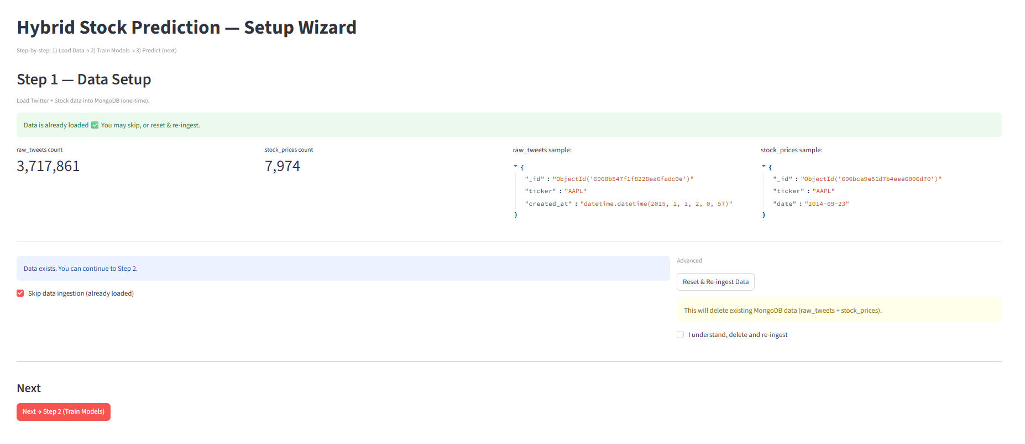
Figure 10: Data Setup interface displaying current database statistics and data ingestion controls
8.1.2 Step 2: Training the Models
After completing the data setup, the system navigates users to the Train Models page when they click the navigation button. This stage involves training three separate neural networks that collectively form the hybrid prediction system. The system displays the current status of three model files: the Stock LSTM model, which learns patterns from sixty-day stock price sequences; the Twitter LSTM model, which learns patterns from seventy-two-hour Twitter sentiment windows; and the Hybrid Fusion model, which combines outputs from both encoders to produce the final directional prediction.
The Stock LSTM encoder processes twenty-five features including technical indicators such as RSI, MACD, and Bollinger Bands. The Twitter LSTM encoder processes sentiment scores, tweet counts, and engagement metrics derived from the preprocessed Twitter data. The Hybrid Fusion network integrates the outputs from both modalities to generate a binary classification indicating whether the stock price will move up or down on the following trading day.
For each model, the interface displays whether the trained file exists in the models/trained directory, along with the file modification timestamp and size in megabytes. The full file path is provided for verification purposes. If any models are missing or if users choose to retrain existing models, they initiate the training process by clicking the Train Models button. The system then executes three sequential training pipelines in order.
The first pipeline trains the Stock LSTM model by processing stock price sequences. The second pipeline trains the Twitter LSTM model by processing sentiment sequences. The third pipeline trains the Hybrid Fusion model, which learns to optimally combine the representations from both modalities. Throughout the training process, a progress bar displays completion percentage, advancing from zero through thirty-three percent, sixty-seven percent, and finally to one hundred percent as each model completes its training cycle.
A live log window provides detailed information during training, showing data preprocessing steps including sequence building and train-test split operations. The log displays epoch-by-epoch training metrics, presenting both training loss and accuracy alongside test loss and accuracy for each epoch. The system automatically saves the best model checkpoint whenever test accuracy improves, ensuring that the optimal model state is preserved. Upon completion, final evaluation metrics are displayed in the log window.
When all models finish training, the status changes to indicate successful completion, all three model indicators reflect the presence of trained files, and file sizes appear in the interface, typically ranging from five to twenty megabytes each. At this point, the navigation button to proceed to Step 3 becomes enabled. Users may optionally skip training if all models already exist, and this option is automatically selected when the system detects existing model files. Alternatively, users can force retraining by selecting the corresponding option, which deletes existing models before initiating new training runs. This feature is useful for experimentation with different hyperparameters or when users wish to retrain on updated data.
The expected duration for the complete training process is approximately thirty to forty minutes when utilizing GPU acceleration. The Stock LSTM training typically requires ten minutes, the Twitter LSTM training requires approximately fifteen minutes, and the Fusion model training completes in about five minutes. Training metrics should be interpreted as follows: train accuracy represents model performance on the training data and typically reaches sixty to sixty-five percent, while test accuracy represents performance on unseen data with a target range of fifty-four to fifty-six percent, which is marginally above the fifty percent random baseline. The loss values indicate model fit quality, with lower values representing better fit to the data.

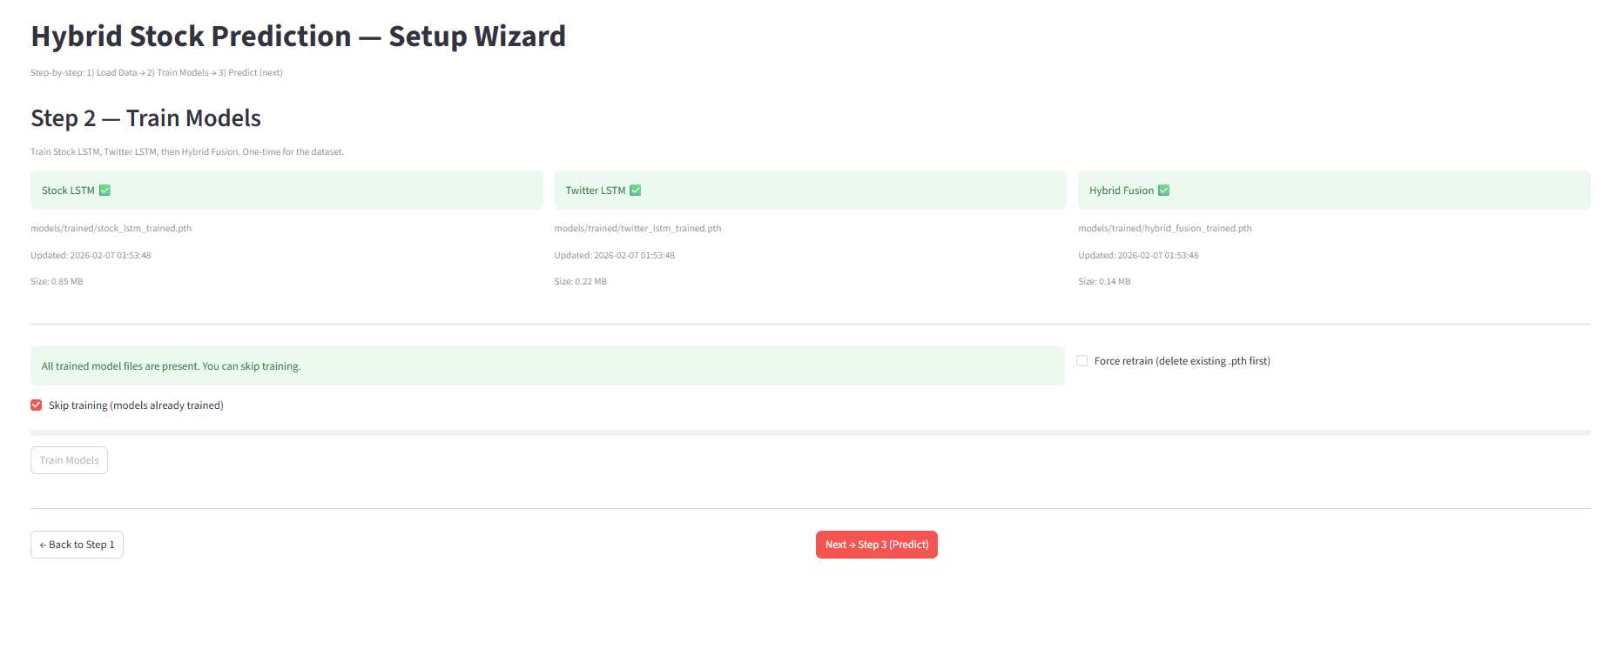
Figure 11: Model training status dashboard
8.1.3 Step 3: Viewing Predictions and Results
Once model training completes successfully, users navigate to the prediction interface by clicking the appropriate navigation button. This page allows users to select specific stocks and dates to view the model's predictions along with comprehensive visualizations of the results. The prediction interface consists of several components that enable interactive exploration of the model's performance.
The first component is the dataset selection interface, which presents radio buttons allowing users to choose between the test dataset split or the train dataset split. The test split is selected by default, as it represents unseen data that was not used during the training process and therefore provides a more accurate assessment of model generalization capability. The second component is the ticker selection dropdown menu, which lists all available stock tickers. Users select the company they wish to analyze from this menu.
The third component is the date selection interface, implemented as a calendar date picker that shows all available prediction dates from the dataset. The interface defaults to the most recent date in the dataset. If a user selects a date for which no data is available, the system automatically uses the closest previous trading day and displays an informational message indicating which date was actually used for the prediction.
Upon selecting a ticker and date, the system immediately displays comprehensive prediction results organized into several sections. The first section presents a Stock Information Panel displaying five key metrics in a columnar layout. These metrics include the actual trading date that was analyzed, the closing price on that day, the trading volume, the opening price, and the percentage change from open to close. This information provides context for interpreting the model's prediction.
The second section displays an Actual versus Derived Price Projection Chart for the last thirty trading days of the selected ticker. The blue line shows actual closing prices retrieved from MongoDB. The model output is a binary direction prediction (Up/Down) and an Up probability per day. The red line is not a direct regression output; it is a derived visualization computed by applying the predicted direction and a confidence-based scaling factor to the previous day's close, producing a projected curve for visual comparison. This derived curve is used only for interpretability and does not represent a true price forecast produced by the model. When the blue and red lines track closely together, this indicates that the model successfully predicted price direction. Conversely, divergence between the lines indicates prediction errors where the model's forecast did not align with actual market movements.
The third section presents Single-Day Prediction Metrics for the specifically selected date. Three key metrics are displayed: the Predicted Trend, which shows either "Up" or "Down" as the binary classification result; the Up Probability, which presents a numerical probability value ranging from zero to one indicating the likelihood that the price will rise; and the Confidence metric, which expresses the model's conviction in its prediction as a percentage. The probability interpretation follows standard conventions where values greater than 0.5 predict upward movement and values less than 0.5 predict downward movement. The confidence metric is calculated as the maximum of the probability and one minus the probability, multiplied by one hundred percent, such that higher values indicate stronger model conviction in the prediction.

For example, if the system displays a Predicted Trend of "Up" with an Up Probability of 0.687 and a Confidence of 68.7 percent, this indicates that the model predicts an upward price movement with moderately high confidence. Users can interpret such predictions as relatively strong signals, whereas predictions with confidence values near fifty percent indicate high uncertainty and should be treated with appropriate caution.

Navigation within the prediction interface allows users to return to the model training page using the back navigation button. Users may select different tickers or dates to explore additional predictions, and the interface dynamically updates all visualizations based on these selections without requiring page reloads. This interactive exploration capability allows users to validate model performance across different stocks and time periods, providing comprehensive insights into prediction accuracy, consistency, and the conditions under which the model performs well or poorly.

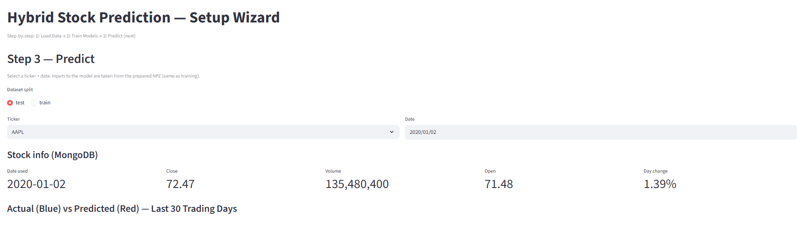
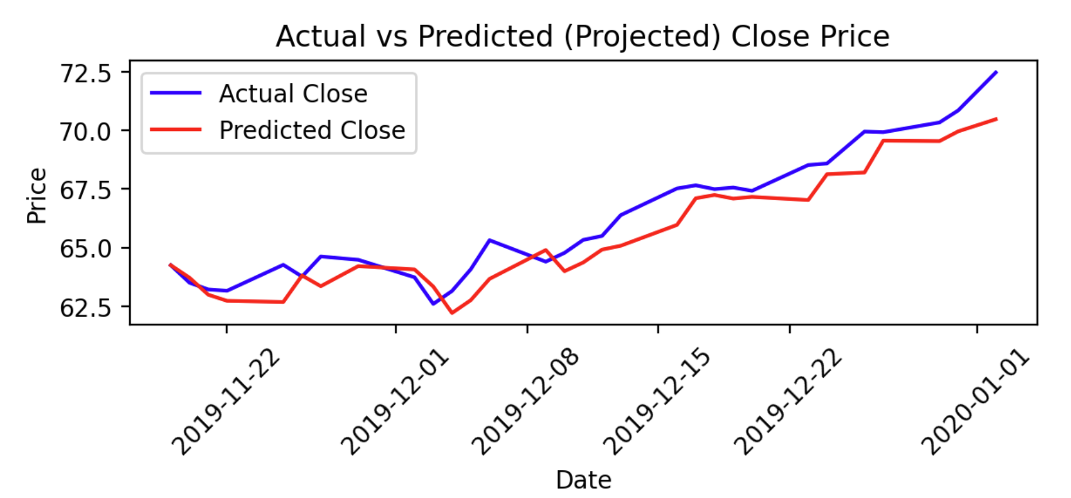
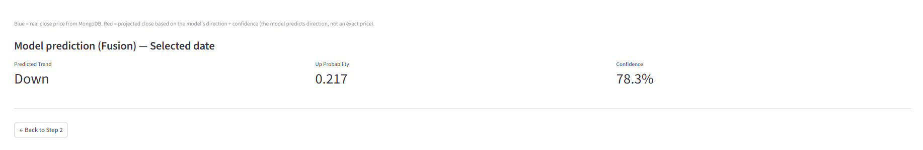
Figure 12: Prediction interface with ticker selection, date picker, and visualization controls
8.2 Features Overview
The multimodal stock prediction system integrates several advanced features designed to enhance its predictive capability and provide a comprehensive user experience. The following components represent the core technical innovations that distinguish this hybrid approach from traditional single-source prediction systems.
8.2.1 Dual-Modality LSTM Architecture
At the core of the system's capability is the dual-encoder LSTM architecture, which processes two independent data streams simultaneously. This feature enables the model to capture both quantitative market dynamics and qualitative public sentiment, representing a fundamental departure from unimodal prediction systems that rely solely on price history or sentiment alone.
The Stock LSTM Encoder processes sixty-day sliding windows of historical price data, where each day is represented by 25 feature dimensions. The feature vector includes Open, High, Low, Close, Adjusted Close, log-transformed volume, and 19 technical indicators designed to capture trend, momentum, volatility, and market dynamics. These indicators include returns and momentum features, moving averages (SMA and EMA at 10-day and 20-day windows), volatility measures (rolling standard deviation), RSI, MACD components (line, signal, histogram), and Bollinger Bands (upper, middle, lower, and band width). The encoder architecture implements a two-layer LSTM with one hundred twenty-eight hidden units and an attention mechanism, producing a one hundred twenty-eight dimensional feature vector that encodes price patterns and technical trends. The complete technical specification is provided in Section 3.5.
The Twitter LSTM Encoder processes seventy-two-hour sliding windows of aggregated tweet sentiment, with each hour represented by ten feature dimensions derived from sentiment class probabilities, polarity metrics, activity levels, and momentum indicators. The encoder architecture implements a two-layer LSTM with sixty-four hidden units and an attention mechanism, producing a sixty-four dimensional feature vector encoding sentiment dynamics and public discourse patterns. The reduced dimensionality compared to the stock encoder reflects a deliberate design choice to prevent the noisier text-derived modality from dominating the fusion process. The complete feature specification and temporal alignment methodology are detailed in Sections 3.6 and 4.2.
This architectural separation allows each encoder to specialize in its respective domain while maintaining sufficient representational power for capturing complex temporal patterns. The attention mechanism plays a critical role by enabling each model to focus on critical time periods, such as sudden price drops or sentiment spikes, that most strongly influence future price movements.
8.2.2 Intelligent Fusion Network
The fusion network represents the key innovation that combines insights from both modalities into a unified prediction framework, addressing the fundamental challenge of integrating heterogeneous data sources that differ in temporal granularity, semantic meaning, and statistical properties. The fusion architecture accepts as input the concatenated feature vectors from both encoders, resulting in a one hundred ninety-two dimensional combined representation.
The network processes this combined representation through a series of hidden layers organized into two functional blocks: the fusion layers and the prediction head. The fusion block consists of two dense layers that progressively reduce dimensionality. The first fusion layer reduces the concatenated representation from one hundred ninety-two dimensions to one hundred twenty-eight dimensions using rectified linear unit activation, followed by dropout regularization at a rate of twenty percent. The second fusion layer further reduces dimensionality from one hundred twenty-eight to sixty-four dimensions, also employing ReLU activation and twenty percent dropout. The prediction head then processes this fused representation through a dense layer reducing from sixty-four to thirty-two dimensions with ReLU activation, followed by a final output layer that maps from thirty-two dimensions to a single dimension. The output layer produces raw logits rather than probabilities, as the system employs Binary Cross-Entropy with Logits Loss during training, which combines the sigmoid activation and loss computation in a single numerically stable operation. The complete fusion architecture and training methodology are described in Section 3.7.
The fusion network employs a carefully designed two-phase training strategy where individual encoders are trained independently on their respective prediction tasks, then frozen while only the fusion layers are trained on temporally aligned multimodal samples. This approach prevents one modality from dominating the learned features and results in a balanced fusion that leverages complementary information from both sources. The decision logic implements a standard binary classification threshold where probability values greater than or equal to 0.5 result in an "Up" prediction, while values less than 0.5 result in a "Down" prediction.
8.2.3 Automated Data Pipeline and Temporal Alignment
To ensure system reliability and data integrity, an automated pipeline handles all preprocessing, alignment, and feature engineering operations. The data collection component retrieves stock data from the Yahoo Finance API and Twitter data from a curated Kaggle dataset, with all raw data stored in MongoDB collections. The preprocessing pipeline implements distinct processing flows for each data modality, including text cleaning, sentiment extraction using pre-trained transformer models, technical indicator calculation, and temporal aggregation. A critical design requirement is the prevention of data leakage, ensuring that predictions are generated using only information that would have been available at the time of prediction. The temporal alignment mechanism and leakage prevention strategy are described in detail in Section 4.2.3. The complete data acquisition and preprocessing procedures are documented in Section 4.
8.3 Troubleshooting
As with any complex data science system, users may encounter various issues when operating the multimodal stock prediction platform. This troubleshooting section addresses common problems and provides solutions to ensure smooth operation.
8.3.1 Common Issues and Solutions
Web Interface Fails to Load or Responds Slowly:
If the Streamlit interface does not load after launching, users should first verify that the Streamlit process is running in the terminal. A successful launch displays a local URL (typically http://localhost:8501). If no URL appears, users should check the terminal for error messages indicating missing dependencies or port conflicts. If the page loads but responds slowly, users should try refreshing the browser, clearing the browser cache, or switching to a different browser. If the problem persists, users should terminate the Streamlit process and relaunch it from the terminal.
Data Ingestion Errors:
During Step 1 (Data Setup), users may encounter errors related to external data sources. Yahoo Finance API failures typically result from network connectivity issues or temporary API rate limits; users should verify their internet connection and retry after a brief waiting period. Kaggle dataset download failures usually indicate missing or misconfigured Kaggle API credentials; users should ensure that a valid kaggle.json file is placed in the appropriate directory as described in Section 8.1.1. MongoDB connection errors indicate that the MongoDB service is not running; users should start the MongoDB service before retrying data ingestion.
Training Takes Longer Than Expected:
Model training duration depends on hardware configuration, dataset size, and whether GPU acceleration is available. Systems without a dedicated GPU will experience significantly longer training times compared to the estimates shown in the interface. If training appears to have stalled, users should examine the log output displayed in the Streamlit interface to verify that training is progressing through epochs. The log should display updated loss and accuracy metrics at regular intervals. Users experiencing out-of-memory errors should reduce the batch size parameter in the training configuration, which decreases memory consumption at the cost of slightly longer training time.
Prediction Accuracy Near Fifty Percent:
Users may observe that the model's test accuracy hovers near fifty percent. This represents expected behavior rather than a system malfunction. Stock price prediction is inherently difficult due to market efficiency and the influence of unpredictable external factors. The research findings presented in Section 5 demonstrate that aggregated Twitter sentiment provides limited additional predictive value for next-day stock direction, and accuracy in the range of fifty-four to fifty-six percent represents a marginally positive result above random baseline. Users should interpret this as a research finding about the limitations of sentiment-based prediction rather than evidence of system failure.
8.3.2 Frequently Asked Questions
What should I do if predictions are not generated after training completes?
Users should verify that all three model files (stock_lstm_trained.pth, twitter_lstm_trained.pth, and hybrid_fusion_trained.pth) exist in the models/trained directory. If any file is missing, the corresponding training step did not complete successfully and should be re-executed. Users should also confirm that the NPZ data files required for prediction are present in the project root directory.
Can I retrain the model on different tickers or date ranges?
The current system is configured to process six predefined technology stocks (AAPL, AMZN, GOOG, GOOGL, MSFT, TSLA) over the 2015–2020 period. Modifying these parameters requires changes to the configuration file (config/db_config.py) and is described in the Maintenance Guide (Section 9). Users should be aware that changing the ticker set or date range requires re-running the entire pipeline from data ingestion through model training.
Why does the predicted price chart differ from actual prices?
The predicted price chart displays a derived projection based on the model's binary direction predictions and confidence levels, not a direct price forecast. The model predicts only the direction of next-day price movement (Up or Down), and the visualization applies these directional predictions to construct an illustrative price trajectory. Divergence between the projected and actual curves reflects prediction errors in direction or magnitude, which are expected given the inherent difficulty of stock market forecasting.
For advanced troubleshooting involving system internals, debugging tools, and infrastructure diagnostics, administrators should refer to Section 9.3 (Troubleshooting and Debugging) in the Maintenance Guide.

9 Maintenance Guide
9.1 System Architecture
The architecture of the multimodal stock prediction system is designed to facilitate seamless data processing, model training, and inference while ensuring scalability, maintainability, and reliability. The system is structured around a modular architecture consisting of three primary layers: the presentation layer, the processing layer, and the data persistence layer. Each layer operates independently while communicating through well-defined interfaces, enabling efficient maintenance and future extensibility.
9.1.1 Presentation Layer Interaction
The presentation layer is built using Streamlit, a modern Python framework for creating interactive web applications for machine learning and data science projects. This layer provides a browser-based user interface that allows users to interact with the system without requiring command-line expertise. The interface is accessible via any modern web browser by connecting to the local server at port 8501. Users can navigate through a three-step wizard that guides them through data setup, model training, and prediction generation.
The Streamlit application manages user interactions through a session state mechanism that preserves user selections and navigation context across page reloads. When users initiate operations such as data ingestion or model training, the presentation layer spawns subprocess calls to execute the appropriate Python scripts, capturing their output in real-time and displaying it through live log windows. This asynchronous execution pattern ensures that the user interface remains responsive during long-running operations, providing continuous feedback about processing progress through streaming console output.
The presentation layer communicates directly with the MongoDB database to retrieve statistical summaries, sample documents, and metadata for display purposes. Additionally, it loads trained model files and preprocessed data sequences to generate predictions on demand. The use of Streamlit's caching decorators ensures that expensive operations such as model loading and data parsing are performed only once per session, significantly improving response times for subsequent interactions.
9.1.2 Processing Layer Functionality
The processing layer constitutes the computational core of the system, responsible for data ingestion, preprocessing, feature engineering, model training, and inference. This layer is implemented as a collection of modular Python scripts organized into logical pipelines corresponding to the three primary workflows: the stock data pipeline, the Twitter sentiment pipeline, and the hybrid fusion pipeline.
Each pipeline follows a consistent structure encompassing data collection, preprocessing with validation and cleaning, feature engineering including technical indicators or sentiment extraction, sequence generation with sliding window construction, and model training using PyTorch-based LSTM architectures. The stock pipeline processes historical OHLCV data from Yahoo Finance, computing nineteen technical indicators and creating sixty-day sliding windows. The Twitter pipeline processes tweets from a Kaggle dataset through text cleaning, RoBERTa-based sentiment scoring, hourly aggregation, and seventy-two-hour window construction. The fusion pipeline aligns both datasets by ticker and date, implementing a two-phase training strategy where pre-trained encoders are frozen and only fusion layers are optimized.
The modular design enables independent development, testing, and maintenance of each component while ensuring consistent temporal alignment and leakage prevention across all stages. Detailed descriptions of each pipeline's implementation, including preprocessing logic, feature engineering algorithms, and training procedures, are provided in Section 4 (Engineering Process).
9.1.3 Data Persistence Layer Management
The system employs MongoDB as its primary data persistence mechanism, providing a NoSQL document-oriented database that efficiently handles the heterogeneous data structures required by different pipeline stages. MongoDB operates as a local service listening on the default port 27017, with all collections stored within a database named StockPredictionDB. The database schema implements six primary collections corresponding to different processing stages.
The raw_tweets collection stores the original Twitter data as loaded from the Kaggle dataset, preserving all original fields including tweet text, creation timestamps, ticker symbols, and engagement metrics. The cleaned_tweets collection stores the preprocessed tweet text after cleaning operations have been applied. The tweets_with_sentiment collection augments each tweet with computed sentiment scores from the RoBERTa model. The hourly_sentiment_tweets collection stores temporally aggregated features grouped by ticker and hour, providing the input data for sequence generation. The stock_prices collection stores daily OHLCV data retrieved from Yahoo Finance. The cleaned_stock_prices collection stores the preprocessed and filtered stock data enriched with computed technical indicators, serving as the input for training sequence construction.
MongoDB's flexible document structure allows each collection to evolve independently as preprocessing stages add or modify fields. The database implements indexing on frequently queried fields such as ticker symbols and temporal fields to ensure efficient retrieval during sequence generation and model inference. Regular maintenance operations including index optimization and data compaction ensure consistent query performance as the dataset grows.
In addition to MongoDB, the system persists processed data and trained models through the local file system. Preprocessed sequence data is stored in NumPy NPZ format, which provides efficient compressed storage for multi-dimensional arrays. Two NPZ files are generated: stock_lstm_training_data.npz containing stock price sequences and twitter_lstm_training_data.npz containing sentiment sequences. Temporal alignment between modalities is computed at runtime through an inner join on (date, ticker) pairs rather than stored as a separate file. Trained model parameters are persisted using PyTorch's state dictionary serialization format, creating PTH files that can be loaded for inference without requiring retraining.
9.1.4 System Dependencies
The multimodal stock prediction system relies on several critical dependencies to function effectively. Understanding these dependencies and their interactions is essential for effective system maintenance and troubleshooting. The core data processing dependencies include pandas version 2.0 or higher for tabular data manipulation and NumPy version 1.24 or higher for numerical array operations. These libraries provide the foundational data structures and operations used throughout all pipeline stages.
The machine learning and deep learning dependencies include PyTorch version 2.0 or higher, which provides the neural network implementation framework and automatic differentiation capabilities. The Transformers library version 4.30 or higher from Hugging Face provides access to pre-trained language models including the RoBERTa sentiment classifier. Scikit-learn version 1.3 or higher provides preprocessing utilities, evaluation metrics, and data splitting functions used during model training and evaluation.
The database connectivity dependency is PyMongo version 4.6 or higher, which implements the MongoDB client protocol in Python and provides the interface for all database operations. The data ingestion dependencies include yfinance version 0.2 or higher for Yahoo Finance API access, kagglehub version 0.2 or higher for Kaggle dataset downloads.
The visualization dependencies include matplotlib version 3.7 or higher and seaborn version 0.12 or higher, which generate the charts and graphs displayed in the user interface and evaluation reports. The presentation layer dependency is Streamlit version 1.28 or higher, which provides the web application framework and user interface components. Additional utility dependencies include tqdm for progress bar displays during batch processing operations.
All dependencies are specified with minimum version requirements in the requirements.txt file located in the project root directory. This file serves as the authoritative specification for recreating the exact environment needed to run the system. Understanding the interactions between these components and their version constraints is vital for effective system maintenance, as incompatibilities between dependency versions can cause runtime errors or degraded performance.
9.2 Regular Maintenance Tasks
To ensure the multimodal stock prediction system operates efficiently, securely, and reliably over extended periods, administrators must perform a series of routine maintenance tasks. These tasks are crucial for preventing potential issues, maintaining data integrity, optimizing system performance, and ensuring long-term sustainability of the deployment.
9.2.1 Virtual Environment Setup
The system requires Python 3.8 or higher with all dependencies installed in an isolated virtual environment. Administrators should create one using Python's built-in venv module in the project root directory. Activation is performed via the Scripts\Activate script on Windows or bin/activate on Unix-based systems. After activation, all dependencies are installed by running pip install -r requirements.txt.
PyTorch may require platform-specific installation commands depending on whether GPU (CUDA) support is available. Administrators should consult the PyTorch documentation for the appropriate installation command if the default pip install fails.
For ongoing maintenance, administrators should periodically run pip install --upgrade -r requirements.txt to incorporate security patches and bug fixes. If an update introduces breaking changes, rolling back to previous versions can be done by pinning the older version numbers in requirements.txt and reinstalling.
9.2.2 Data Backup Procedures
Regular data backups are essential to safeguard against data loss due to hardware failures, software errors, accidental deletions, or security incidents. The multimodal stock prediction system stores data in two primary locations: the MongoDB database and the local file system. Comprehensive backup procedures must address both storage mechanisms to ensure complete data protection.
For MongoDB backups, administrators should utilize MongoDB's native mongodump utility to create BSON exports of all collections within the StockPredictionDB database. Backups should be scheduled at regular intervals using operating system task schedulers (cron on Unix systems or Task Scheduler on Windows), with each backup operation creating a timestamped directory to enable point-in-time recovery. Administrators should establish a retention policy balancing storage constraints against recovery point objectives.
Offsite storage of backups is critical for disaster recovery. Backup directories should be automatically synchronized to remote storage locations such as network-attached storage, remote file servers, or cloud storage services immediately after each backup completes. Regular testing of backup restoration procedures ensures that backups are complete, uncorrupted, and can be successfully restored when needed.
For file system data including NPZ sequence files, PTH model checkpoints, and configuration files, administrators should implement similar backup procedures using file synchronization tools. These files contain the results of expensive preprocessing and training operations that may require hours or days to regenerate. File backups should be synchronized to the same offsite storage locations as database backups, maintaining consistency in backup management procedures.
9.2.3 Log Management
The system generates logs through three main channels: pipeline script output (data processing and training progress), Streamlit application logs (web server activity and user interactions), and MongoDB server logs (database operations and query performance).
Pipeline Logs: During interactive use, pipeline output is displayed in real-time through the Streamlit interface. For automated or scheduled operations, administrators should redirect standard output and standard error to timestamped log files to preserve execution traces for later analysis.
MongoDB Logs: These are written to the location specified in the MongoDB configuration file and are particularly useful for diagnosing slow queries and connection issues. Administrators should consult their MongoDB installation documentation to locate the log directory.
Retention: Administrators should define a log retention policy appropriate to their storage capacity, using OS-level log rotation tools to automatically manage file sizes. Older logs can be compressed or archived, and periodic log reviews should be scheduled to identify recurring errors, performance trends, and security-relevant events.
9.2.4 Security Maintenance Practices
The system processes financial data and predictive models that may have commercial value, making security practices important for maintaining data integrity and system availability.
Dependency Updates: Administrators should periodically run pip-audit within the virtual environment to scan for known vulnerabilities in installed Python packages, and upgrade affected packages promptly. Subscribing to security advisories for key dependencies (PyTorch, MongoDB, Transformers) ensures timely awareness of critical patches.
MongoDB Security: Default MongoDB installations lack authentication enforcement. Administrators should enable authentication with role-based access control, and bind the database to 127.0.0.1 (localhost only) in the MongoDB configuration to prevent unauthorized remote access. For deployments requiring remote connectivity, TLS encryption and IP-restricted firewall rules should be applied.
Application Access: In single-user development environments, access control for the Streamlit interface may be unnecessary. Production deployments should implement authentication through reverse proxy servers or network-level restrictions, and administrators should periodically review and revoke unused credentials.
9.3 Troubleshooting and Debugging
Effective troubleshooting and debugging are essential skills for maintaining the integrity and performance of the multimodal stock prediction system. When issues arise during operation, employing systematic diagnostic strategies helps identify root causes efficiently and implement appropriate solutions.
9.3.1 Diagnosing Common Problems
Systematic problem diagnosis begins with clearly characterizing the observed symptoms and gathering relevant contextual information. Administrators should document the specific error messages, unexpected behaviors, or performance anomalies that users report, along with information about when the issue first appeared, whether it occurs consistently or intermittently, and what operations were being performed when the problem manifested.
Reproducing the issue in a controlled environment represents a critical diagnostic step. Administrators should attempt to recreate the problem using the same inputs, configuration settings, and operational sequence that triggered the original issue. Successful reproduction confirms that the problem is systematic rather than transient and provides a test case for validating potential solutions. If reproduction attempts fail, this suggests the issue may be related to specific environmental conditions or transient states that no longer exist.
Log file examination provides invaluable diagnostic information. Administrators should review logs from the period when the issue occurred, searching for error messages, warning conditions, or stack traces that indicate the point of failure. Python exception traces are particularly informative, showing the exact sequence of function calls that led to an error and identifying the specific line of code where execution failed. MongoDB logs may reveal database errors such as connection failures, timeout conditions, or constraint violations that prevented operations from completing successfully.
Common problem patterns in the multimodal stock prediction system include MongoDB connection failures typically caused by the database service not running or incorrect connection parameters in the configuration file, data loading failures often resulting from network connectivity issues when accessing external APIs or missing Kaggle API credentials, memory exhaustion during training on systems with insufficient RAM for the batch sizes configured in training scripts, and model loading errors due to incompatible checkpoint files created with different PyTorch versions.
For data quality issues where preprocessing or training produces unexpected results, administrators should validate input data integrity by querying sample records from MongoDB and verifying their completeness and correctness. Missing or corrupted data can cause preprocessing failures or degrade model performance. The temporal alignment between stock and Twitter data deserves particular scrutiny, as misalignment can cause training failures or introduce data leakage artifacts that artificially inflate reported accuracy.
9.3.2 Using Debugging Tools
Debugging tools enable deep inspection of system state and execution flow, facilitating identification of subtle issues that are not apparent from log messages alone. Integrated development environments such as Visual Studio Code and PyCharm provide sophisticated debugging capabilities including breakpoint setting, step-through execution, variable inspection, and expression evaluation. Administrators can load any Python script into these IDEs, set breakpoints at lines of interest, and execute the script in debug mode. When execution reaches a breakpoint, the debugger pauses and allows inspection of all variables in scope, examination of call stacks to understand execution context, and step-by-step advancement through subsequent code lines.
The Python debugger pdb provides command-line debugging capabilities for environments where IDE usage is impractical. Administrators can insert pdb.set_trace() calls at strategic locations in the code to trigger debugging sessions, after which pdb provides an interactive shell for examining state and controlling execution flow. This approach proves particularly useful for debugging issues that occur in production environments or during automated batch processing where IDE attachment is not feasible.
Profiling tools identify performance bottlenecks and resource consumption patterns. The cProfile module included with Python generates detailed reports showing how much time execution spends in each function, how many times each function is called, and the total cumulative time including sub-function calls. Administrators can use these profiles to identify unexpectedly slow operations and target optimization efforts effectively. Memory profilers such as memory_profiler track memory allocation over time, helping diagnose memory leaks where memory consumption grows without bound during long-running operations.
For MongoDB-related issues, the MongoDB Compass graphical interface provides visual tools for exploring database contents, examining index usage, and analyzing query performance. Administrators can construct and test queries interactively, view query execution plans to understand how MongoDB processes them, and identify missing indexes or inefficient query patterns. The MongoDB profiler can be enabled to capture slow queries for analysis, providing insights into database performance issues.
Network analysis tools become relevant when diagnosing connectivity issues between system components or with external services. Tools such as netstat show active network connections and listening ports, helping verify that MongoDB is accepting connections on the expected port. Packet capture tools like tcpdump or Wireshark can examine network traffic to diagnose protocol-level issues, though these are rarely necessary for the relatively simple network architecture of the stock prediction system.
9.3.3 Handling System Recovery
Recovery procedures depend on the nature of the failure. For database corruption, MongoDB's mongod --repair command can recover databases after unclean shutdowns. If repair fails, administrators should restore from the most recent backup using mongorestore, which supports selective restoration of individual collections to minimize data loss. For training failures, administrators should delete any incomplete checkpoint files and restart training. The modular architecture allows retraining individual components independently, so a failed Twitter LSTM training does not require retraining the Stock LSTM. If a dependency upgrade introduces breaking changes, administrators can revert by pinning the previous version in requirements.txt and reinstalling, as described in Section 9.2.1. For complete system loss, a full rebuild is achievable with proper backups of database contents, model checkpoints (.pth files), preprocessed data (.npz files), and configuration files, by recreating the virtual environment and restoring from backups.
9.4 Documentation and Updates
Keeping documentation up-to-date is a fundamental aspect of effective system maintenance and ensures successful knowledge transfer among team members over time. As the multimodal stock prediction system evolves through bug fixes, performance optimizations, and feature enhancements, the documentation must evolve in parallel to remain accurate and useful.
9.4.1 Importance of Up-to-Date Documentation
Accurate and current documentation ensures consistency across operations by providing a single authoritative reference for system functionality, configuration, and procedures. It facilitates onboarding of new team members, who can quickly learn the system architecture and workflows without relying solely on ad-hoc knowledge transfer. Documentation also improves troubleshooting efficiency by recording known issues and proven resolution steps, and serves as institutional memory that preserves expertise even as team composition changes over time.
9.4.2 Strategies for Effective Knowledge Transfer

Documentation should be stored in version control (e.g., Git) alongside the project source code, enabling change tracking, collaborative updates, and access to previous versions. Administrators should schedule periodic reviews to verify that documented procedures, configuration examples, and troubleshooting guides remain aligned with the current system state. When administrators solve novel problems or implement configuration changes, they should update the relevant documentation as part of the same workflow. Documentation should include not only procedures but also rationale explaining why a configuration value was chosen or what diagnostic reasoning underlies a troubleshooting step, so that future maintainers can adapt to novel situations rather than mechanically following steps that may not apply.

10 References
[1] Boroumand, O., & Doaei, M. (2024). Developing a stock market prediction model by deep learning algorithms. Journal of Information Technology Management, 16(3), 115–131.
[2] Gupta, H., & Jaiswal, A. (2024). A study on stock forecasting using deep learning and statistical models. arXiv preprint, arXiv:2402.06689.
[3] Mukherjee, S., Sadhukhan, B., Sarkar, N., Roy, D., & De, S. (2021). Stock market prediction using deep learning algorithms. CAAI Transactions on Intelligence Technology, 8, 82–94.
[4] Ouf, S., El Hawary, M., Aboutabl, A., & Adel, S. (2024). A deep learning-based LSTM for stock price prediction using Twitter sentiment analysis. International Journal of Advanced Computer Science and Applications, 15(12), 207–218.
[5] Patel, V., & Tandel, S. (2025). A comparative analysis of LSTM and GRU models enhanced with technical indicators for stock forecasting. ResearchGate.
[6] Sebastian, A., & Tantia, V. (2024). Deep learning for stock price prediction and portfolio optimization. International Journal of Advanced Computer Science and Applications, 15(9), 926–934.
[7] Selvin, A., Vinayakumar, R., Gopalakrishnan, E. A., Menon, V. K., & Soman, K. P. (2017). Stock price prediction using LSTM, RNN and CNN-sliding window model. In International Conference on Advances in Computing, Communications and Informatics (ICACCI) (pp. 1643–1647).
[8] Tarek, M. A., Osman, H., & Elgohary, A. F. M. (2024). Integrating LSTM and transformer-based sentiment for stock price forecasting. Journal of Economic Analysis, 4(3), Article 109.
[9] Wan, X. (2023). Stock price prediction of high-tech industry based on LSTM and GRU: Tesla, Ferrari, and Walmart. Highlights in Science, Engineering and Technology, 76, 585–590.
[10] CardiffNLP. (n.d.). Twitter RoBERTa – Sentiment. Hugging Face. https://huggingface.co/cardiffnlp/twitter-roberta-base-sentiment
[11]FinBERT (ProsusAI/finbert). (n.d.). FinBERT. Hugging Face. https://huggingface.co/ProsusAI/finbert
[12]Hugging Face. (n.d.). Transformers documentation. https://huggingface.co/docs/transformers
[13]Kaggle. (n.d.). Tweets about the Top Companies from 2015 to 2020. https://www.kaggle.com/datasets/omermetinn/tweets-about-the-top-companies-from-2015-to-2020
[14]Kagglehub. (n.d.). Kagglehub Python Package. https://github.com/Kaggle/kagglehub
[15]MongoDB Documentation. (n.d.). MongoDB Manual. https://www.mongodb.com/docs/manual/
[16] NumPy Documentation. (n.d.). https://numpy.org/doc/
[17]Pandas Documentation. (n.d.). pandas. https://pandas.pydata.org/
[18] Python Software Foundation. (n.d.). Python programming language. https://www.python.org/
[19]PyTorch Documentation. (n.d.). https://pytorch.org/docs/
[20] scikit-learn. (n.d.). Machine learning in Python. https://scikit-learn.org/
[21] Streamlit Documentation. (n.d.). https://docs.streamlit.io/
[22] tqdm. (n.d.). A Fast, Extensible Progress Bar for Python. https://github.com/tqdm/tqdm
[23] Yahoo Finance. (n.d.). https://finance.yahoo.com/
[24] yfinance GitHub. (n.d.). https://github.com/ranaroussi/yfinance

